**Delta-X Applications Workshop Instructions**

Table of Contents

**Section 1: Introduction** **2**

**Section 2: Tutorials** **4**

**Section 3: QGIS** **6**

Installing QGIS 6

Testing QGIS 8

***Section 4: Python*** ***10***

Installing Anaconda 10

Installing Packages 11

Testing Jupyter Notebook 16

**Section 5: ANUGA** **19**

Installing ANUGA software 19

**Section 6: Delft3D** **22**

Installing Delft3D 22

**Section 7: Google Colab** **23**

Setting up Colab 23

**Section 8: Data Access** **30**

Module Data 35

Field Data 35

AVIRIS-NG 36

AirSWOT 36

UAVSAR 38

ANUGA 40

Delft3D 39

# 

# Section 1: Introduction



The Delta-X mission is a 5-year NASA Earth Venture Suborbital-3 mission to study the Mississippi River Delta in the United States, which is growing and sinking in different areas. River deltas and their wetlands are drowning as a result of sea level rise and reduced sediment inputs. The Delta-X mission will determine which parts will survive and continue to grow, and which parts will be lost. Delta-X begins with airborne and in-situ data acquisition and carries through data analysis, model integration, and validation to predict the extent and spatial patterns of future deltaic land loss or gain.

The Applications Workshop Delta-X introduction slides and recordings are linked here:

* [Delta-X Applications Workshop Opening (Agenda)](https://github.com/ornldaac/deltax_workshop_2022/blob/main/slides/DeltaX_Intro_Apps_Workshop_Zheng.pdf)
* [Delta-X Overview](https://github.com/ornldaac/deltax_workshop_2022/blob/main/slides/DeltaX_Overview_Apps_Workshop_Simard.pdf)
* [Delta-X Data Management Plan and Data Access](https://github.com/ornldaac/deltax_workshop_2022/blob/main/slides/DeltaX_DataOverview_Apps_Workshop_Jones.pdf)
* [Delta-X Applications Workshop Introduction Recording](https://youtube.com/playlist?list=PLO2yB4LGNlWq9KE_7Er7EIYDF6Yj9MOV2)

You can find more information about the Delta-X mission and datasets here:

* + [2021_Delta-X_Open_Data_Workshop_Introduction.pdf](https://deltax.jpl.nasa.gov/science/presentations/2021-open-data-workshop/2021_Delta-X_Open_Data_Workshop_Introduction.pdf) (Introduction to Delta-X)
  + [2021_Delta-X_Open_Data_Workshop_Datasets.pdf](https://deltax.jpl.nasa.gov/science/presentations/2021-open-data-workshop/2021_Delta-X_Open_Data_Workshop_Datasets.pdf) (Info on Delta-X datasets)
  + [2021_Delta-X_Open_Data_Workshop_ORNL_DAAC.pdf](https://deltax.jpl.nasa.gov/science/presentations/2021-open-data-workshop/2021_Delta-X_Open_Data_Workshop_ORNL_DAAC.pdf) (Introduction to ORNL archive)
  + [2021_Delta-X_Open_Data_Workshop_Website.pdf](https://deltax.jpl.nasa.gov/science/presentations/2021-open-data-workshop/2021_Delta-X_Open_Data_Workshop_Website.pdf) (Introduction to DeltaX website)

Affiliation: Jet Propulsion Laboratory, California Institute of Technology

Acknowledgement: The research was carried out at the Jet Propulsion Laboratory, California Institute of Technology, under a contract with the National Aeronautics and Space Administration (80NM0018D0004)

**These instructions were provided specifically for participants in the 2-day workshop but may not be relevant beyond that. The ORNL DAAC cannot support the platforms that were specific to the workshop.**

**Workshop Overview:**

This workshop introduces users to Delta-X datasets and steps for analyzing field, airborne, and modeling datasets. These tutorials do not require any previous experience, but if you wish to explore these datasets further, experience with Python, GIS, and remote sensing would be beneficial.

These tutorials are designed to be used in [Google Colab](https://colab.research.google.com/), an only version of Jupyter Notebook, that requires no installation or data download. The only requirements are a Google account and internet access. If you don’t wish to install the software on your personal computer, please skip to Section 4: Google Colab.

However, this manual includes steps to install all software needed for the tutorials for participants who want to run the tutorials on their own computers. Installation instructions should work for Mac, PC, and Linux, but specific configuration of your computer may lead to unexpected difficulties. We’ve done our best to address common issues but can’t guarantee that installation will work for every computer.

Software:

QGIS – Open-source GIS software for visualizing and processing geospatial data

Python – Open-source software for installing multiple Python tools

ANUGA – Open-source python-based modeling software

Delft3D – Open-source C and Fortran-based modeling software

Your instructors:

Field Data – Alex Christensen

AVIRIS-NG – Daniel Jensen

AirSWOT – Michael Denbina

UAVSAR – Talib Oliver Cabrera

ANUGA – Kyle Wright

Delft3D – Luca Cortese

**To start installing, please download the Installation_Files., which can be downloaded** [**here**](https://github.com/ornldaac/deltax_workshop_2022/tree/main/Installation_Files). **Create a new folder on your computer (DeltaX_Workshop), and move everything into DeltaX_Workshop, which will be your working directory.**

Installation_Files

* QGIS
  + Test_raster.tif (an example raster file for testing your QGIS installation)
* Python
  + Test_data.ipynb (an example notebook for testing your Python installation)
* ANUGA
  + anuga_core-main.zip (installation file for ANUGA)
* Delft3D
  + Delft3D Hydro-Morphodynamics 4.04.01 Windows.zip (installer)
  + Delft3D_workshop_Delta-X project.lic (license file)
  + Delft3D-Installation_Manual.pdf (additional installation manual)

# Section 2: Tutorials

There are 6 tutorials in the workshop, one for each of the data and model components. Each tutorial contains a few modules. You can follow these tutorials directly using the github links or you can watch the recordings for more detailed instructions. You will find links to slides, python notebooks, and recordings for each tutorial below.

All tutorials except Delft3D are designed to run in Google Colab, which can be setup using instructions in **Section 7**. However, for more customizable and in-depth analysis, we recommend installing software and downloading data to run these notebooks on your own computer. Instructions for installing software are described in **Sections 3-6 (QGIS, Python, ANUGA, Delft3D)**, and the data download instructions are described in **Section 8** (the file path in the notebooks must be changed to the appropriate directory on your own computer).

© 2022 California Institute of Technology. Government sponsorship acknowledged

Tutorial 1: Field Data

Instructor: Alex Christensen

Notebooks: <https://github.com/ornldaac/deltax_workshop_2022/tree/main/tutorials/DeltaXWorkshop_Field>

Slides: <https://github.com/ornldaac/deltax_workshop_2022/blob/main/slides/DeltaX_FieldData_Apps_Workshop_Christensen.pdf>

Recording: <https://youtu.be/22OaPduBsb8>

Tutorial 2: AVIRIS-NG

Instructor: Daniel Jensen

Notebooks: <https://github.com/ornldaac/deltax_workshop_2022/tree/main/tutorials/DeltaX_Workshop_AVIRIS-NG>

Slides: <https://github.com/ornldaac/deltax_workshop_2022/blob/main/slides/DeltaX_AVIRISNG_Apps_Workshop_Jensen.pdf>

Recordings:

Part I: <https://youtu.be/Ht9JdXmzKZI>

Part II: <https://youtu.be/Ddkd2B7YG0Q>

Tutorial 3: AirSWOT

Instructor: Michael Denbina

Notebooks: <https://github.com/ornldaac/deltax_workshop_2022/tree/main/tutorials/DeltaX_Applications_Workshop_AirSWOT>

Slides: N/A

Recording: <https://youtu.be/PkuNEhInoQo>

Tutorial 4: UAVSAR

Instructor: Talib Oliver Cabrera

Notebooks: <https://github.com/ornldaac/deltax_workshop_2022/tree/main/tutorials/deltax_applications_workshop>

Slides: N/A

Recordings:

Part I: <https://youtu.be/WBjDbxfVQKI>

Part II: <https://youtu.be/q6BsxX8Bezk>

Tutorial 5: ANUGA Model

Instructor: Kyle Wright

Notebooks: <https://github.com/ornldaac/deltax_workshop_2022/tree/main/tutorials/ANUGA_DXWorkshop>

Slides: <https://github.com/ornldaac/deltax_workshop_2022/blob/main/slides/DeltaX_ANUGA_Apps_Workshop_Wright.pdf>

Recording: <https://youtu.be/Vee-pPyRefg>

Tutorial 6: Delft3D Model

Instructor: Luca Cortese

Notebooks: <https://github.com/ornldaac/deltax_workshop_2022/tree/main/tutorials/Delft3D>

Slides: <https://github.com/ornldaac/deltax_workshop_2022/blob/main/slides/DeltaX_Delft3d_Apps_Workshop_Cortese.pdf>

Recording: <https://youtu.be/RcGytRMDDIE>

# 

# Section 3: QGIS

## 

## Installing QGIS

QGIS is a great tool for processing remote sensing data and especially useful for visualizing data quickly and effectively. It is open-source and can be downloaded here:

<https://qgis.org/en/site/forusers/download.html>

For Windows:

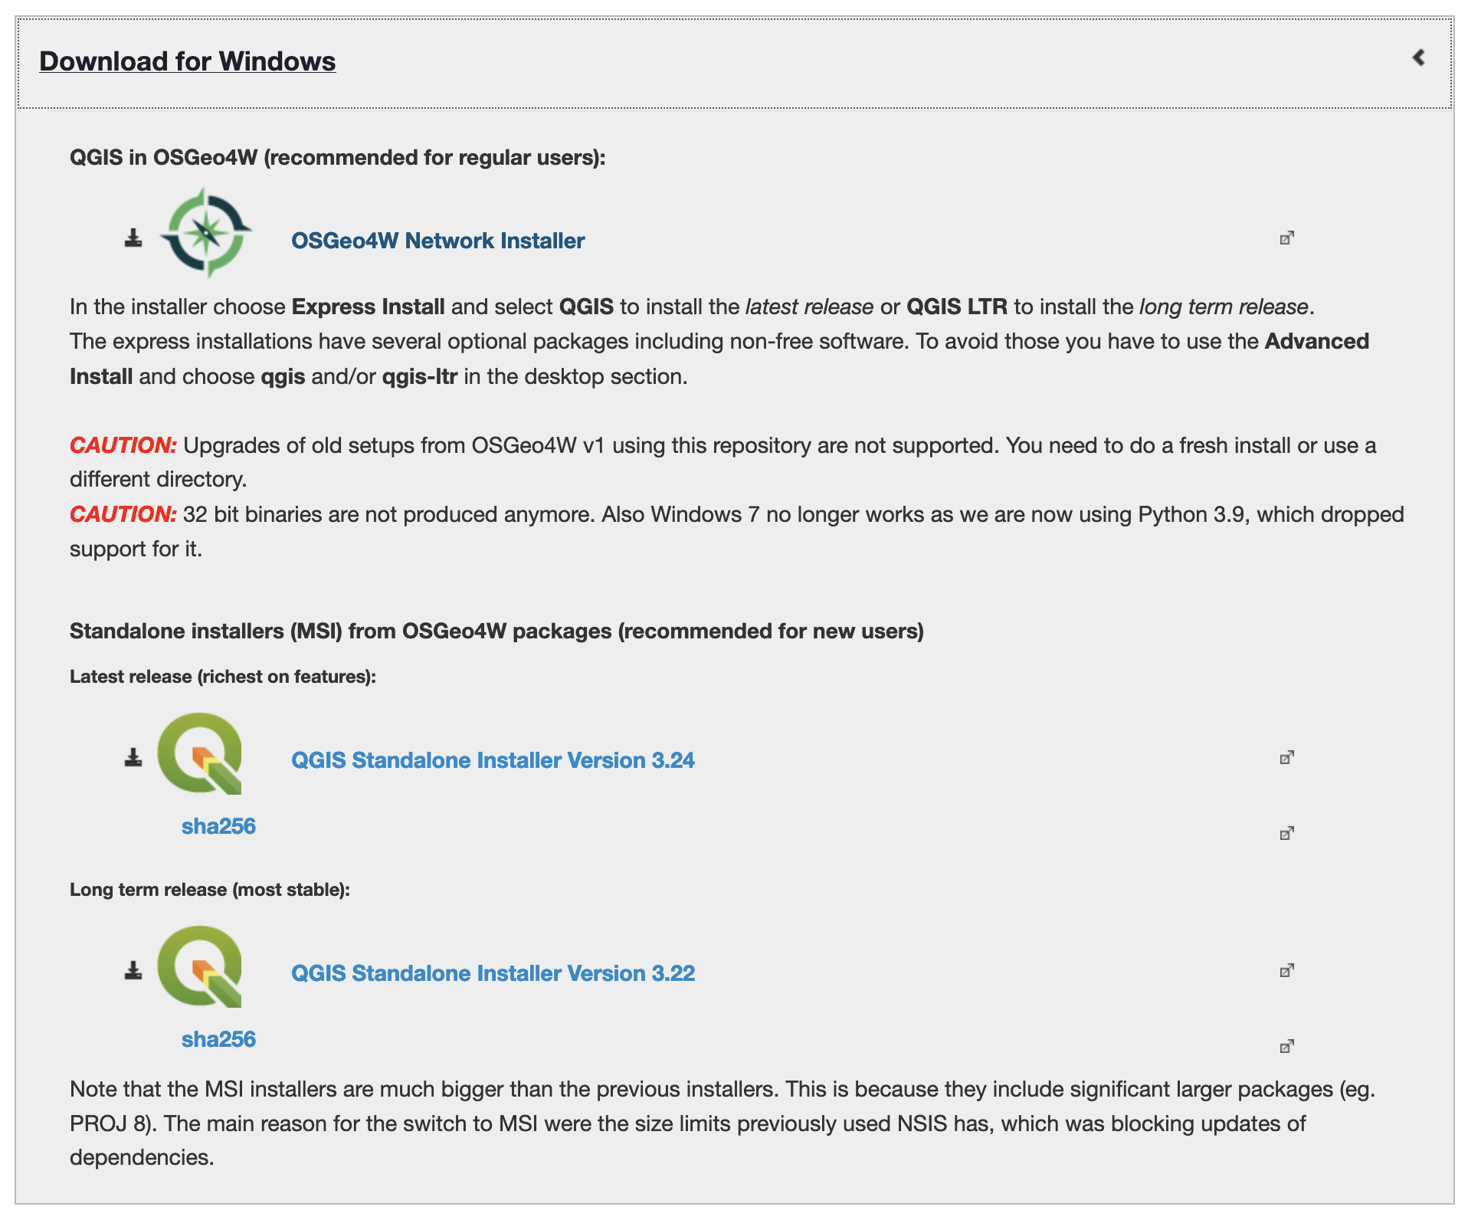

We recommend the standalone installers, specifically Version 3.22

For Mac:

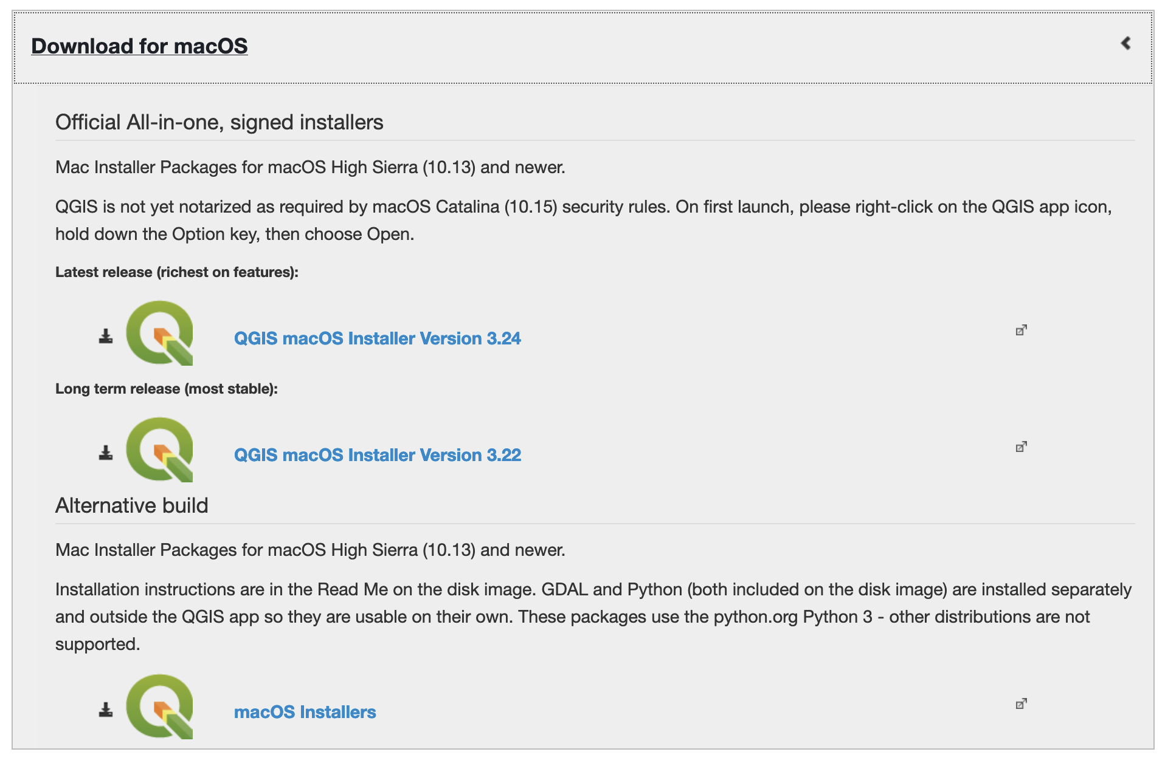

We recommend Version 3.22

For Linux:

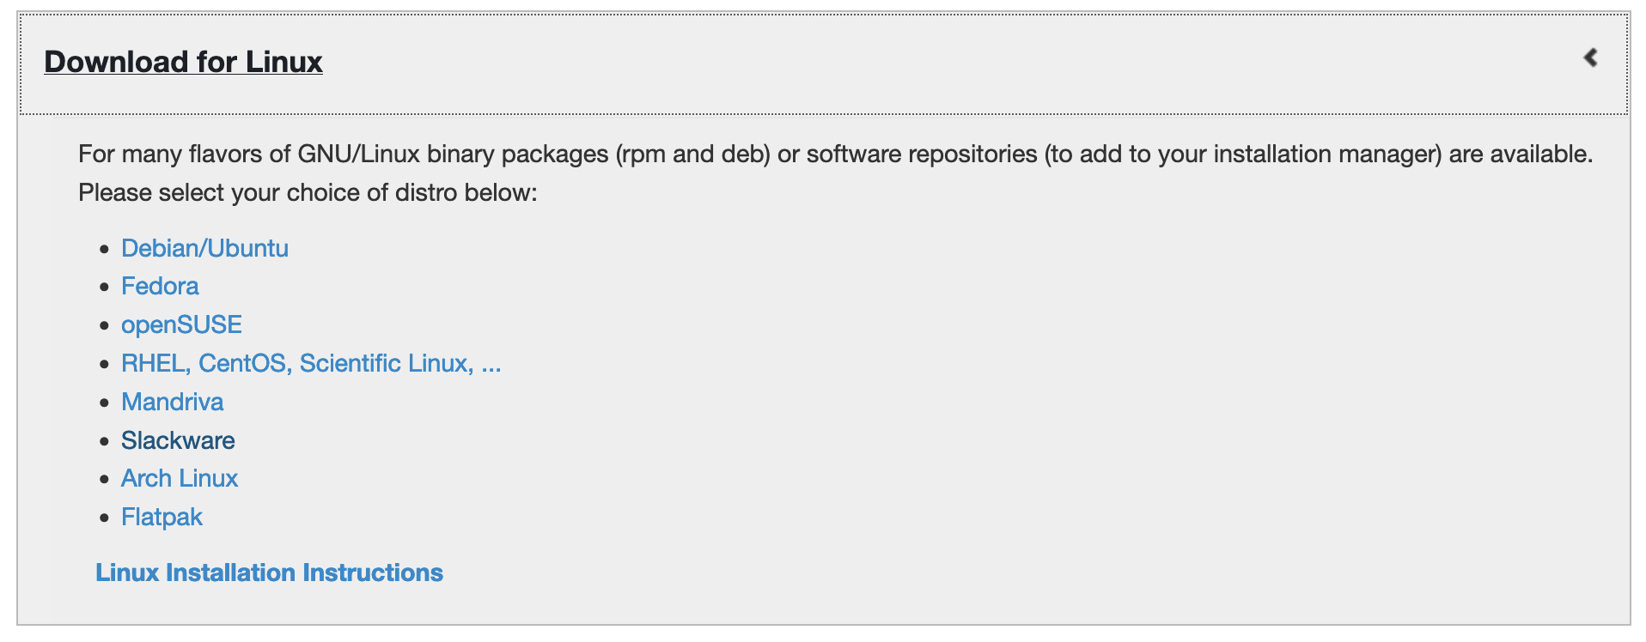

Common issues:

* If you’re using a PC and get error 2503 or 2503, you need to set permissions on C:\\WINDOWS\TEMP to Authenticated users = Full Control
  + More info [here](https://www.urtech.ca/2016/02/solved-how-to-fix-error-2503-2502-on-windows-10-when-installing-software/)

## Testing QGIS

Once you have installed QGIS, run the application. Find the **Layer** tab, select **Add Layer**, and then select **Add Raster Layer …**

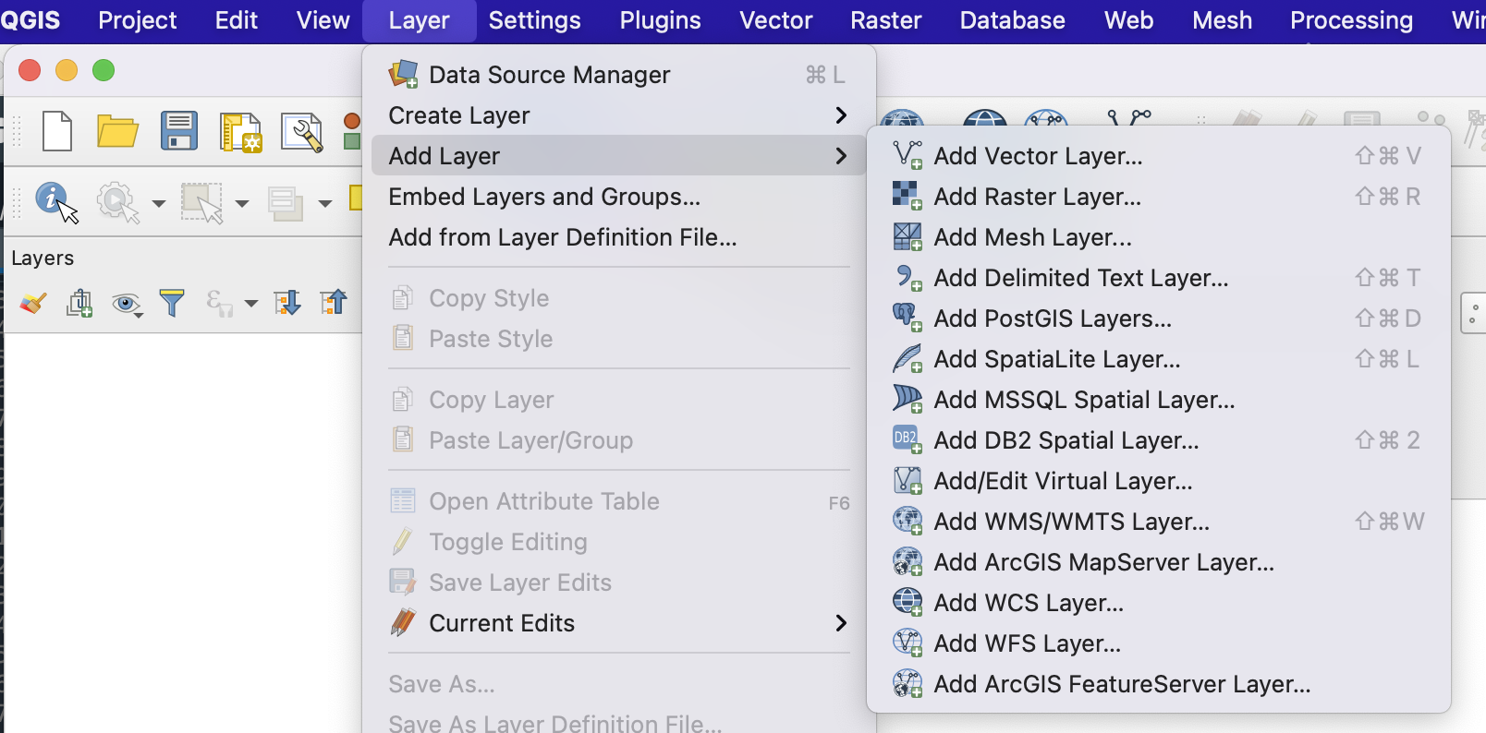

When the Data Source Manager window opens, browse through your files (click the button with three small dots) to find the DeltaX_Workshop/Installation_Files/QGIS/Test_Raster.tif file and click **Open**. Then click **Add** at the bottom of the Data Source Manager window.

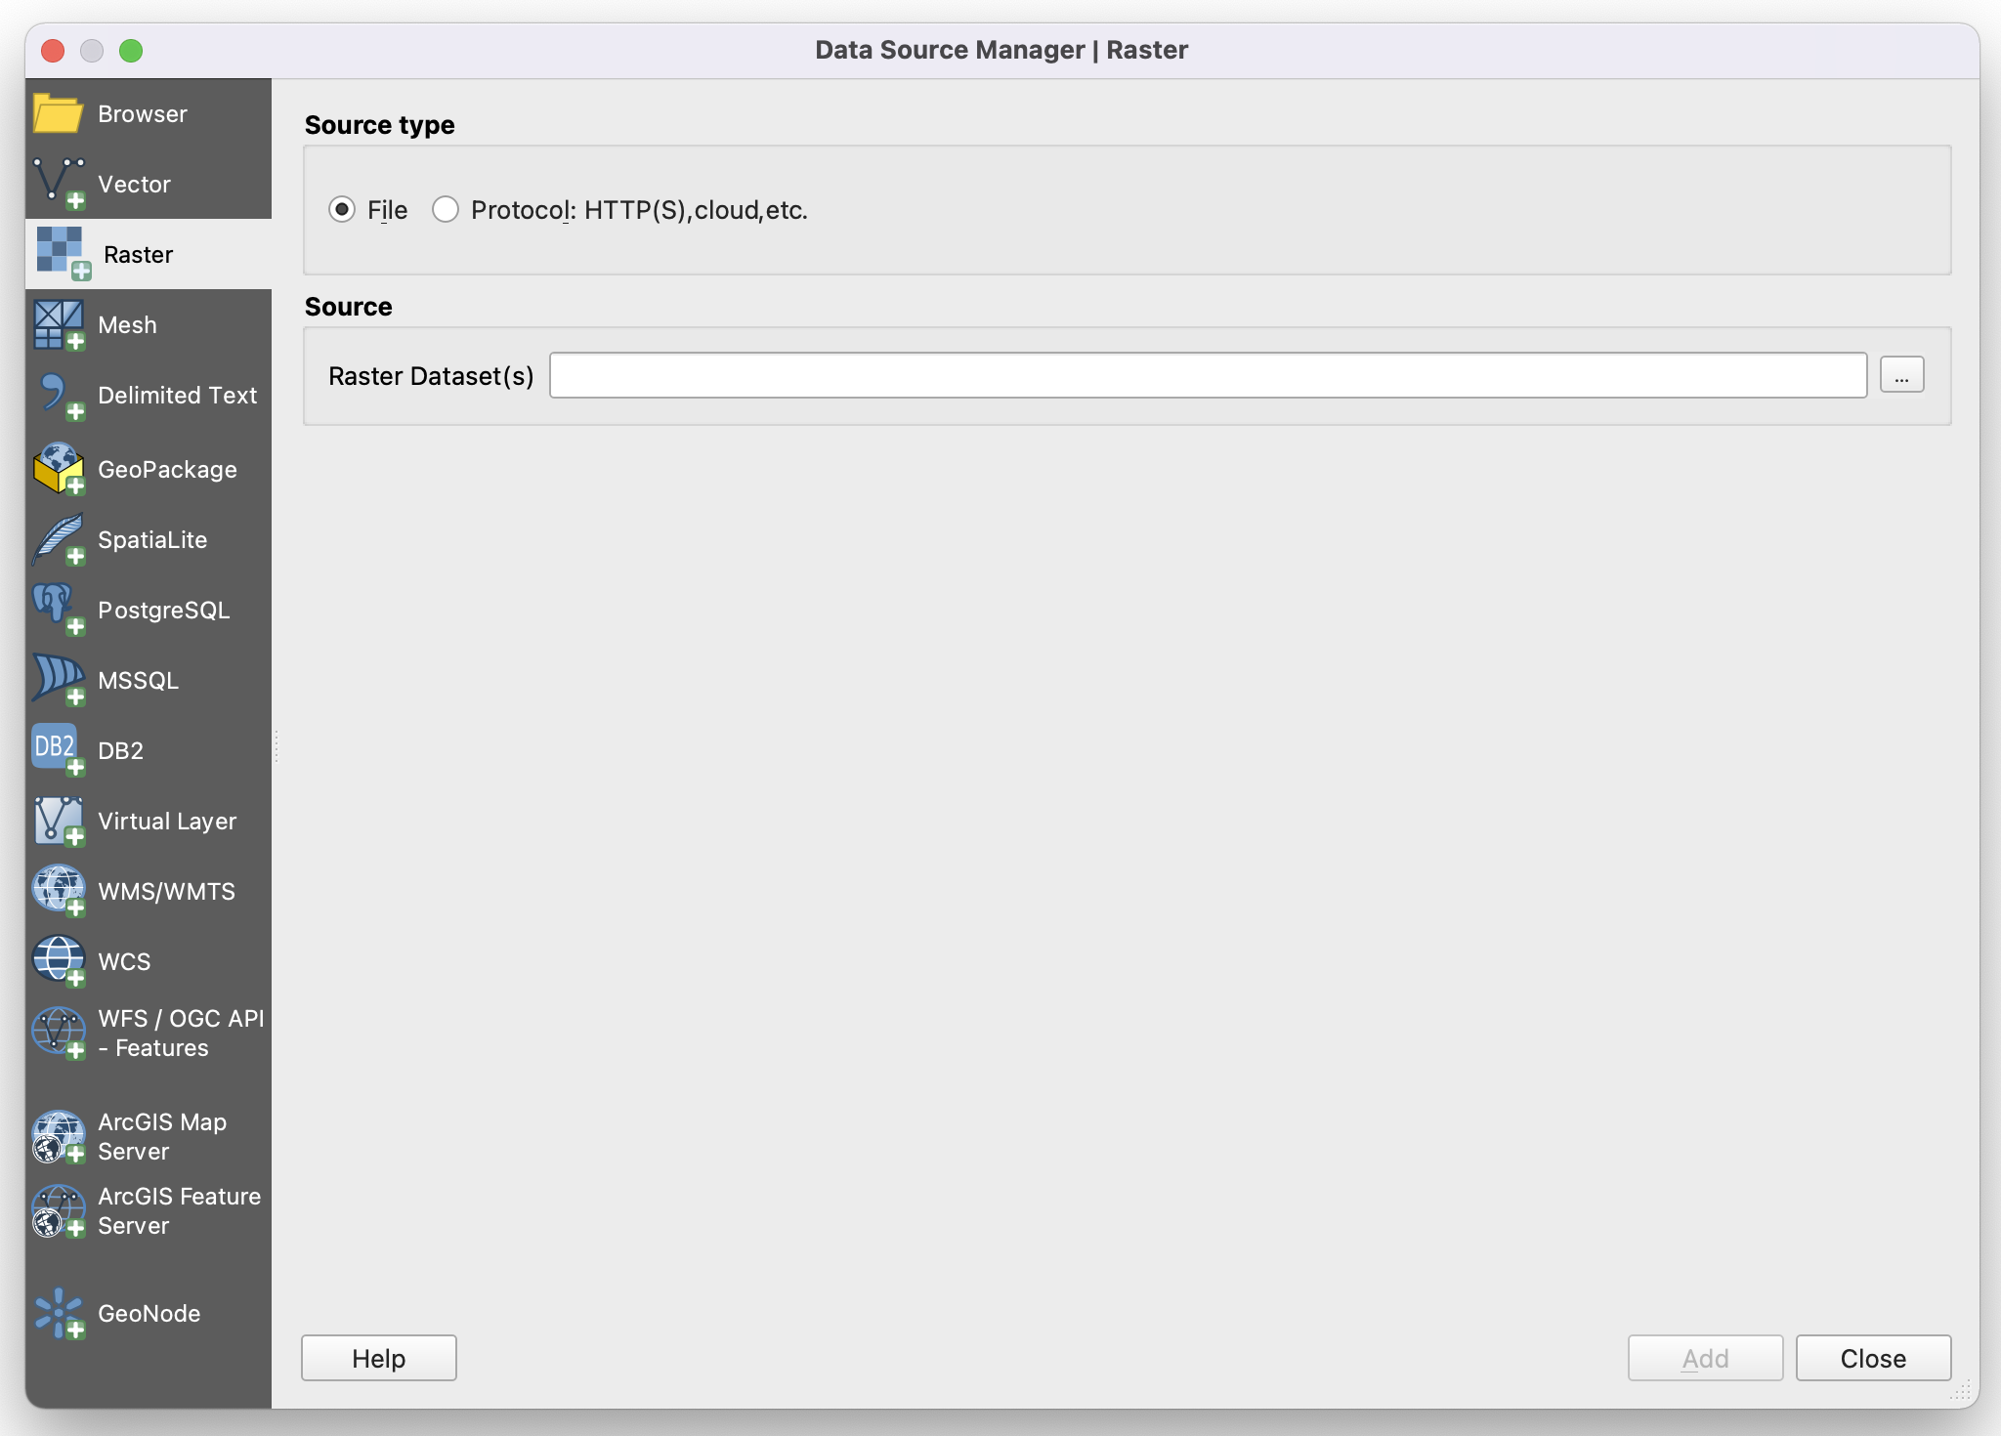

If you have no issues visualizing the file and it looks similar to the image below (but maybe different colors), then QGIS is ready to go.

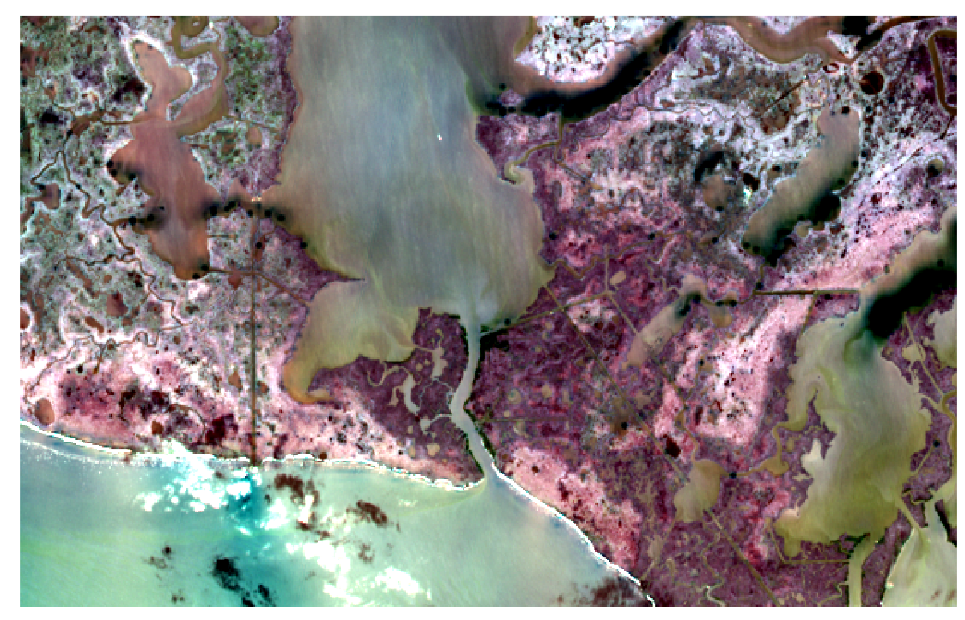

# Section 4: Python

Python will be the most important tool for this workshop. It’s easy to use, open-source, and has many packages that are great for geospatial analysis.

The combination of your operating system and the Python version you install will change your experience with installing packages. Several issues and solutions are discussed below, but remember you can always run the workshop tutorials through Google Colab (Section 4).

## Installing Anaconda

Follow the installation instructions for your operating system:

For Windows:

<https://docs.anaconda.com/anaconda/install/windows/>

For Mac:

<https://docs.anaconda.com/anaconda/install/mac-os/>

For Linux:

<https://docs.anaconda.com/anaconda/install/linux/>

Once you have Anaconda installed, please test it by launching the application. You should see a window that looks similar to this (you should see Spyder and Jupyter Notebooks):

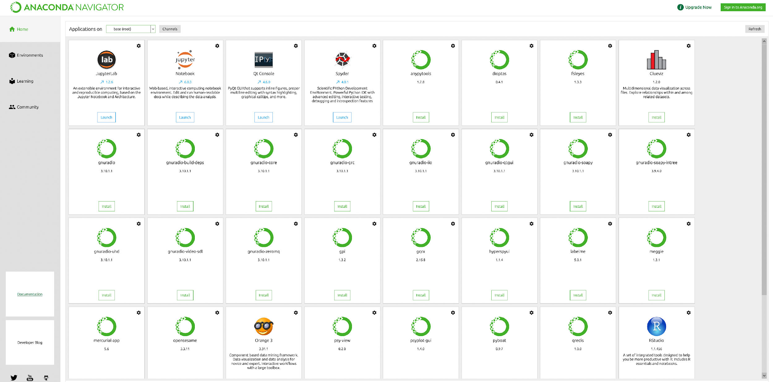

## Installing Packages

You will need several packages for the workshop, which can easily be installed via Anaconda or the command line. If you’re comfortable with the command line, see instructions below. Either way, please try Python version 3.7 - this has the highest success rate so far. We’ll discuss further below.

**Install via Anaconda Navigator**

First, start by creating a new environment. In Anaconda Navigator, you do this by going to the Environments tab and clicking Create.

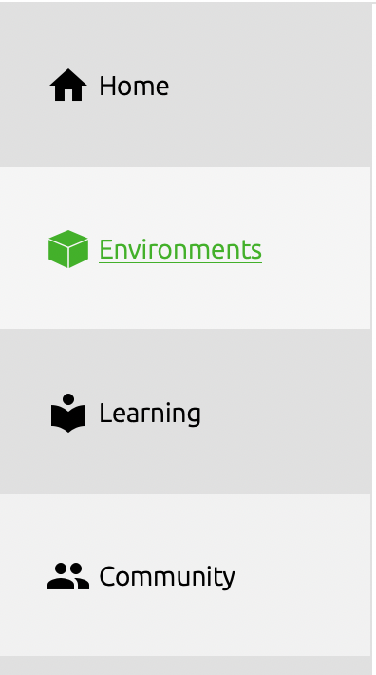 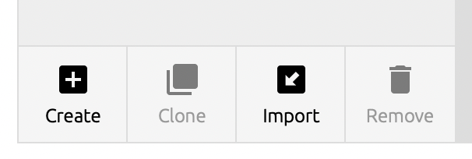

Give the new environment the name DeltaX.

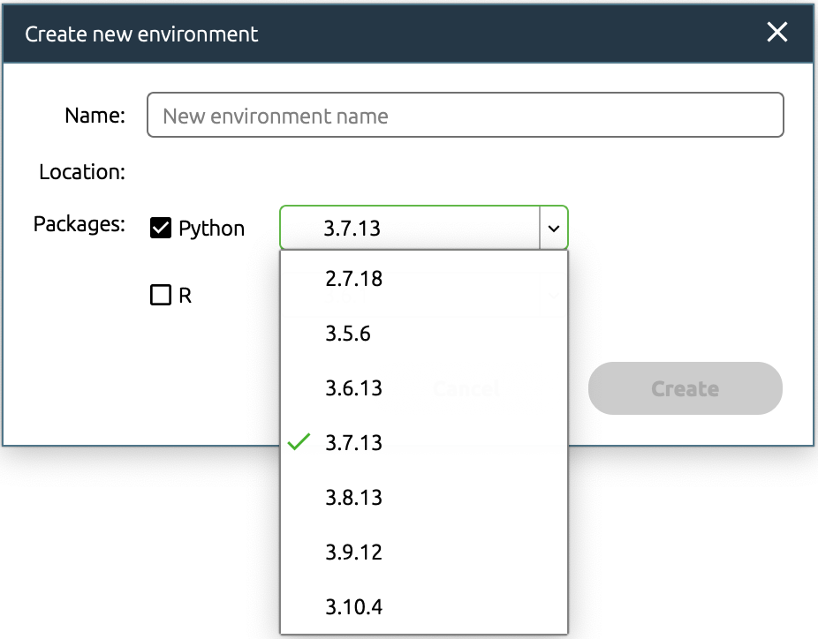

Once you click Create, a new environment will be created (this may take some time).

You will now see the DeltaX environment list on the left. Select this environment and begin installing packages.

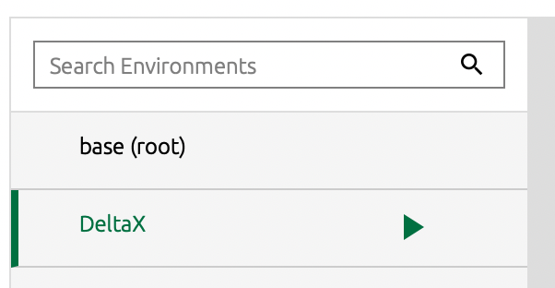

To install a package, select “Not installed” and search for each package.



Check the box next to the desired package and continue until you’ve selected of the following packages:

Numpy

Matplotlib

Gdal

Pandas

Geopandas

Scikit-learn

Scikit-image

Scipy

Cython

Netcdf4

Nose

Dill

Future

Gitpython

Jupyter

Rasterio

If you choose ‘Selected’ from the drop-down menu, you should see all of the packages selected for installation. Make sure to clear the search box to see all the selected packages. You can now click Apply at the bottom of the window and the packages will be installed.

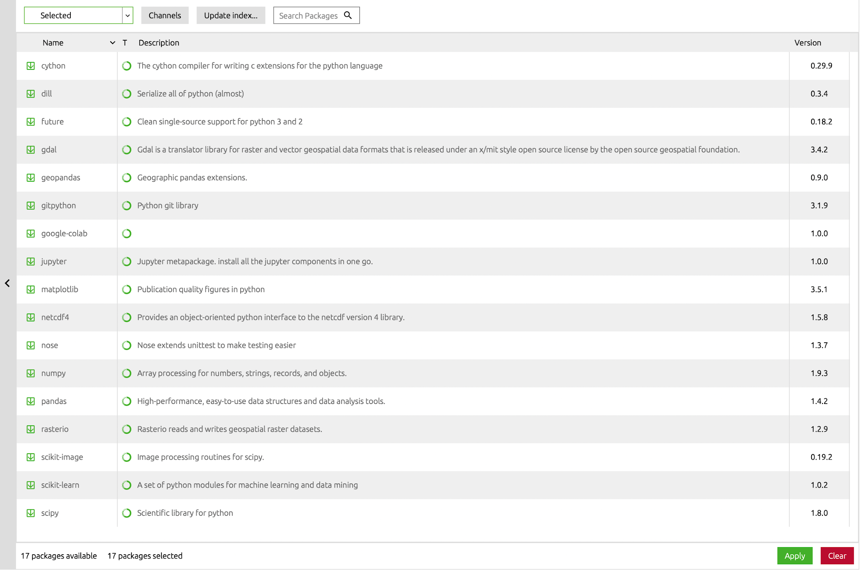

**Install Via Command Line**

You can also create a new environment and install the packages in the command line.

**The biggest difference between MAC and PC command lines are the symbols / and \. For MAC, you use /. For PC, you use \ in the command line or \\ within python or jupyter notebook.**

**Red font represents text to enter into the command line

For Windows:

Open the command prompt (Start menu → search for ANACONDA prompt)

Within the window that opens, navigate to your working folder. For example:

cd \PATH_TO_FOLDER\DeltaX_Workshop\Installation_Files\ANUGA\anuga_core-main

You will need to change “PATH_TO_FOLDER” to be your own path for your working direction

For Mac:

Open a new terminal (Finder → Applications/Utilities/Terminal.app

Within the window that opens, navigate to your working folder. For example:

cd /PATH_TO_FOLDER/DeltaX_Workshop/Installation_Files/ANUGA/anuga_core-main

You will need to change “PATH_TO_FOLDER” to be your own path for your working direction

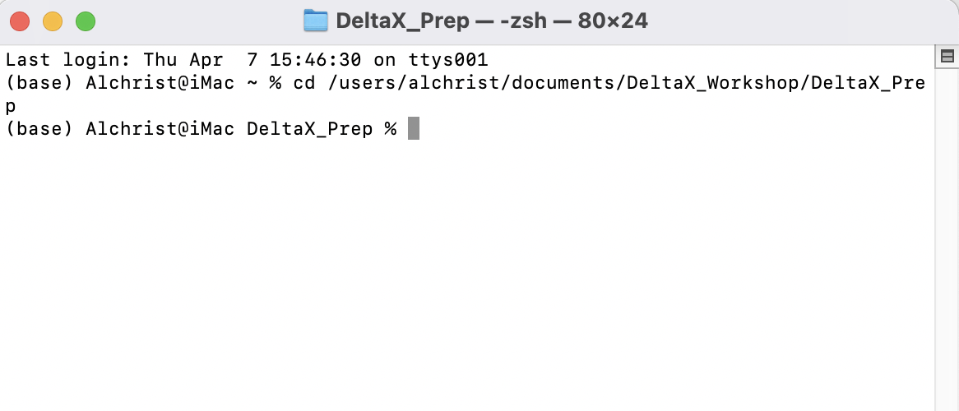

For Mac or Windows:

Once you have navigated to your working directory, type the following in the command window

conda create --name DeltaX python=3.7 numpy matplotlib gdal pandas scikit-learn scikit-image cython scipy netcdf4 nose dill future gitpython jupyter rasterio

When prompted with proceed ([y/n]?) type y

**Some common issues:**

* **rasterio gives an error or hangs at “solving environment”**
  + **solution: remove rasterio from the list. If you successfully install the other packages, then you can try to “pip install rasterio”**

When the new environment is created type:

conda activate DeltaX

If you need to add packages in the future, you can do this by running the following:

conda install -c conda-forge XX (where XX is the name of your package)

**If you have unresolvable issues with installing Python, please go to the end of this document to find an alternative, which uses Google Colab and doesn’t require installing Python.**

## Testing Jupyter Notebook

Jupyter Notebook is a great tool for learning Python and testing code. Each training session in this workshop will have a notebook with pre-written code that you can run, modify, and take home for further study. Each segment of code is explained with text. Please take some time to test this notebook. Through this example, you’ll learn how to install packages, get access to data on the Google Drive folder we’ve shared with you, and plot data. If you run into any errors, please let us know immediately so we can work out issues before you come to the workshop. We won’t have time to work out Python issues during the workshop, so please be prepared to participate by asking questions before May 1st.

We will be using Jupyter Notebooks for these exercises. Please try launching Jupyter Notebook with the example file (Test_data.ipynb). To launch Jupyter, open your command line.

For Windows:

Open the command prompt (Start menu → search for ANACONDA prompt)

For Mac:

Open a new terminal (Finder → Applications/Utilities/Terminal.app

For Windows and Mac:

Type this into your command line:

jupyter notebook

This should pull up a new tab in your web browser showing your home directory. Within this tab, please navigate to the folder ‘DeltaX_Workshop/Installation_Files/Python’ within the new folder you created earlier. Your window should look similar to this, with a different directory:

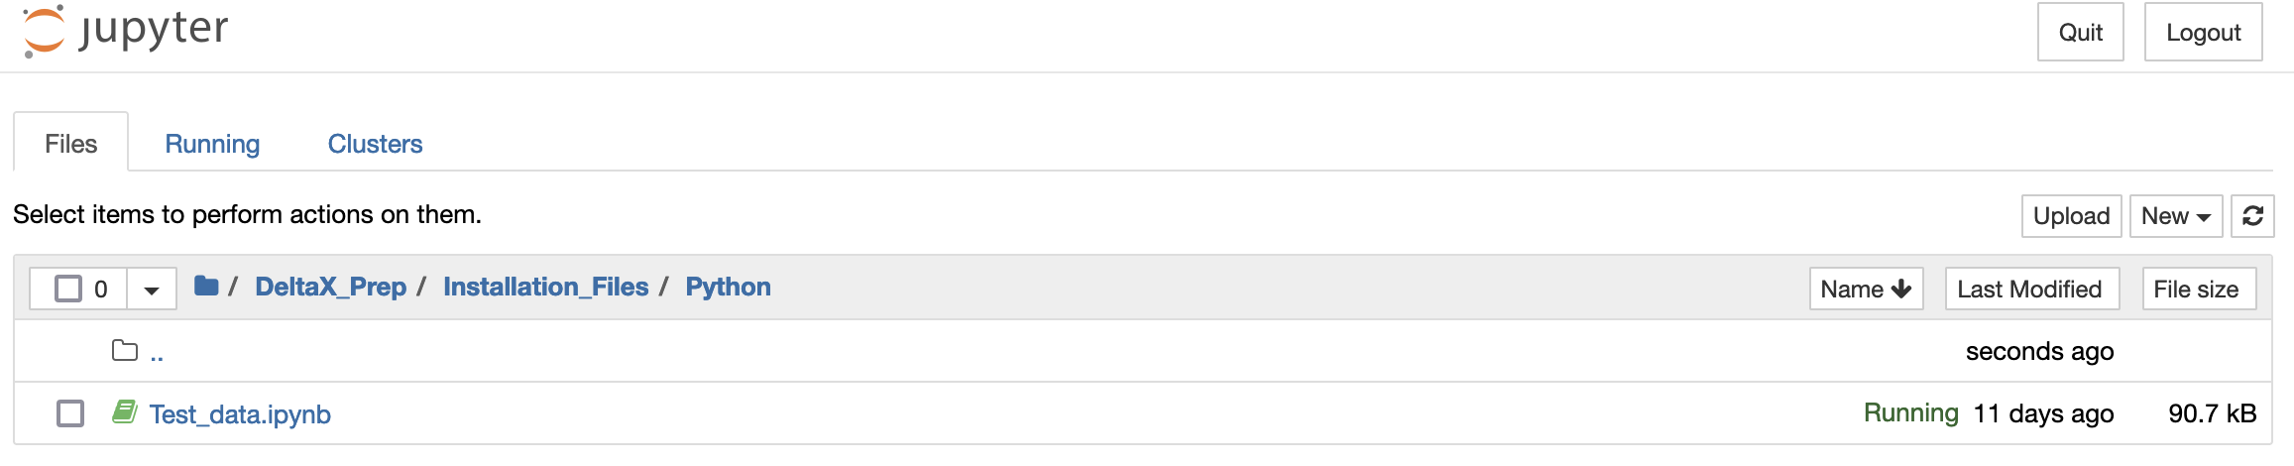

If you click on the Test_data.ipynb file, Jupyter Notebook will open in a new tab:

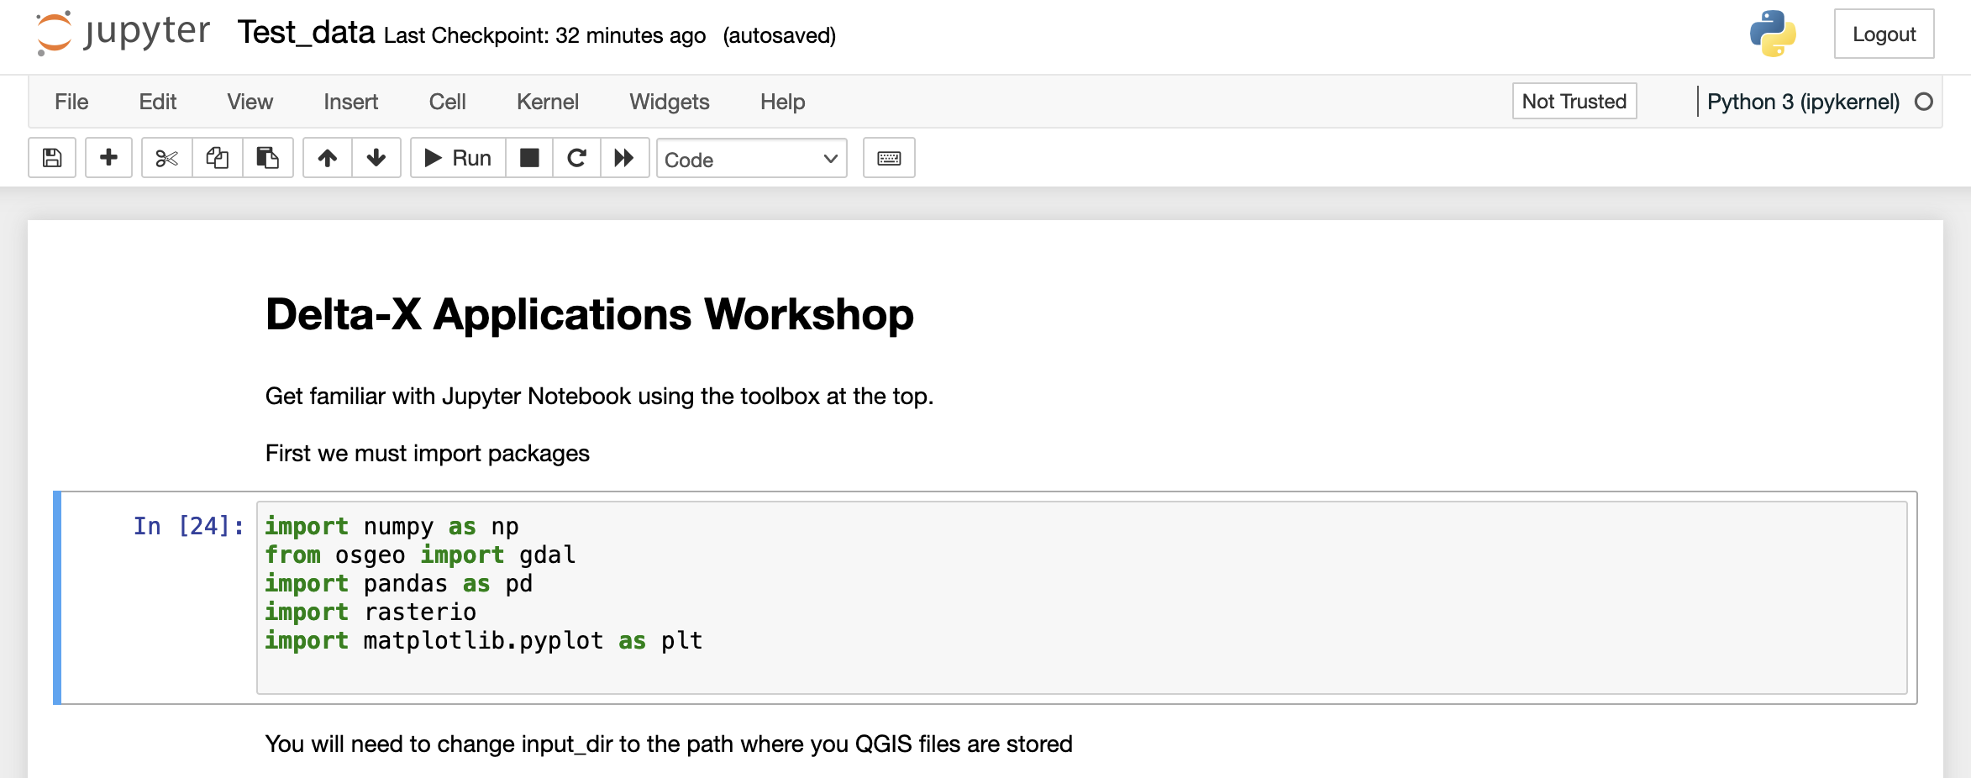

If you launch Jupyter Notebook through Anaconda, there are a few additional steps you need to take.

First, check if nb_conda_kernels is an installed package within your **base** **environment**. If not, please install it there.

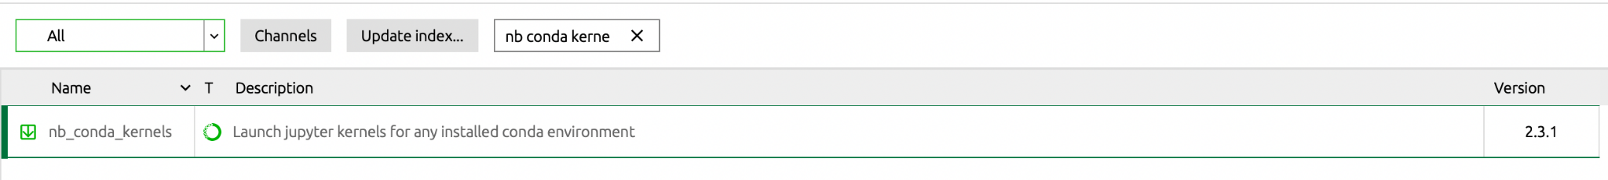

Second, check if ipykernel is installed in your **DeltaX environment**. If not, please install it there.



Third, when you launch Jupyter Notebook through Anaconda, click on Kernel → Change kernel → and select the environment you created.

This should make all of your packages available within the Jupyter Notebook.

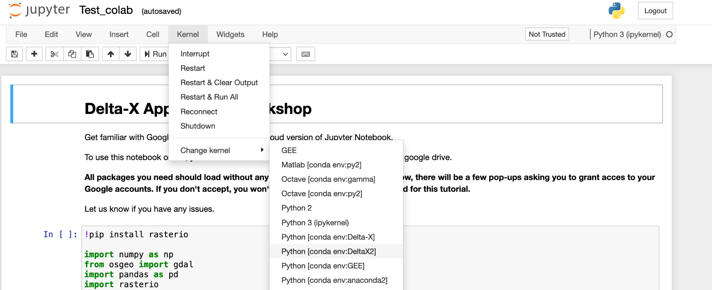

# 

# Section 5: ANUGA

## 

## Installing ANUGA software

ANUGA is an open-source hydrodynamic modeling software we will be using for one training session. It requires a few more steps for installation, building off of the DeltaX environment we installed earlier.

You can find more information about ANUGA here (<https://github.com/GeoscienceAustralia/anuga_core>), but instructions for a simple installation are detailed below.

You will find the anuga_core-main.zip file in the DeltaX_Prep/ANUGA folder included with these instructions. Please unzip this file, creating a folder called anuga_core-main

**Please avoid using spaces in your folder names.**

Before installing this software, you will need to install a few additional packages. This must be done from the command line.

**The biggest difference between MAC and PC command line are the symbols / and \. For MAC, you use /. For PC, you use \ in the command line or \\ within python or jupyter notebook**

For Windows:

Open the command prompt (Start menu → search for ANACONDA prompt)

Within the window that opens, navigate to your working folder. For example:

cd \PATH_TO_FOLDER\DeltaX_Workshop\Installation_Files\ANUGA\anuga_core-main

You will need to change “PATH_TO_FOLDER” to be your own path for your working direction

For Mac:

Open a new terminal (Finder → Applications/Utilities/Terminal.app

Within the window that opens, navigate to your working folder. For example:

cd /PATH_TO_FOLDER/DeltaX_Workshop/Installation_Files/ANUGA/anuga_core-main

You will need to change “PATH_TO_FOLDER” to be your own path for your working direction



For Windows and Mac:

Then you need to activate the python environment you created above. If you skipped that step, please go back and do it now.

Copy the following text into the Terminal and hit return:

conda activate DeltaX

We will now install a few additional packages.

Copy the following text into the Terminal and hit return:

pip install mpi4py triangle Pmw pymetis

If you are using a Mac with a newer installation, you may get an error installing mpi4py and pymetis with pip. If so, please try to conda install these two packages:

conda install -c conda-forge mpi4py pymetis

pip install triangle Pmw

If you are using a PC, you should also install a few additional packages, especially if you have issues:

conda install -c msys2 m2w64-toolchain

conda install -c msys2 libpython

Once completed, we will install ANUGA.

Copy the following text into the Terminal and hit return:

python setup.py install --user

Once completed, we will run some tests.

Copy the following text into the Terminal and hit return:

python runtests.py

If everything runs successfully, this command should finish with ‘OK’ and you are ready to use ANUGA for the workshop. If not, please reach out for assistance.

## 

## 

## 

## 

## 

## 

## 

## 

## 

## 

## 

## 

## 

## 

## 

# 

# Section 6: Delft3D

## 

## Installing Delft3D

Delft3D is another open-source hydrodynamic modeling software that we will be using for the second training session. Unfortunately, Delft3D can only be used on Windows computers, so Mac/Linux users won’t be able to install, but can follow along during the demonstration. In addition, we cannot provide executable or license files. For users interested in compiling Delft3D, please find more information to get started [here](https://oss.deltares.nl/web/delft3d/get-started).

# Section 7: Google Colab

## 

## Setting up Colab

If you have any issues installing python packages, don’t worry. We have a cloud version of the Python Notebooks that can be run online, using Google Colaboratory.

If you successfully installed Python and can run the test Jupyter Notebook, you can skip the steps below.

Google Colab is similar to Jupyter Notebooks, but is run on the Google cloud and comes with many packages already installed. Therefore, it’s a great way to teach tutorials for this workshop. The only requirement will be allowing Colab access to your Google Drive. Unfortunately, Colab cannot access the files on your computer, so we will be accessing data through the shared Google Drive.

Please go through the following steps to practice using Colab.

1. Go to <https://github.com/achri19/DeltaX_Workshop_Setup> to find the Github site where we are hosting the test notebook.

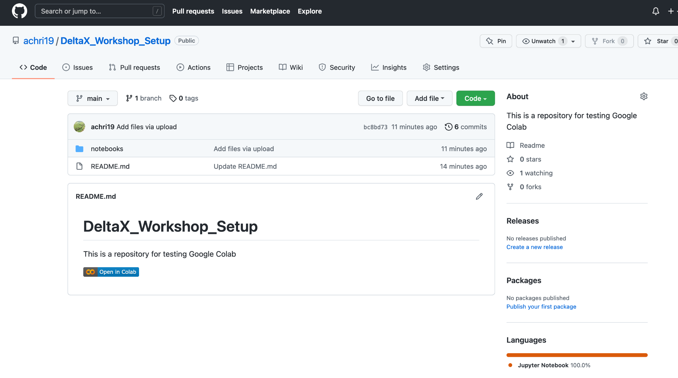

You should not need a Github account to access this repository.

1. Click on the “Open in Colab” button within the README section.

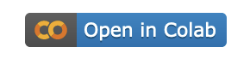

1. This will open a new window and a beautiful test notebook.

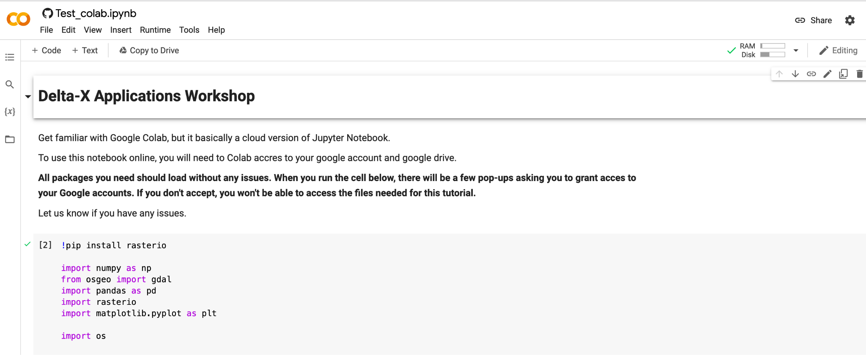

1. Read the instructions
2. When you hover over the first gray box, you will see a “play” button in the upper left corner. **Click it** to run the first cell. You can also use a command to run this cell, often it’s SHIFT + ENTER or CTRL+ENTER, depending on your system. If you hover over the “play” button, it will tell you what the command is.

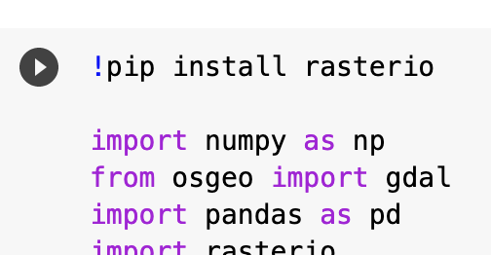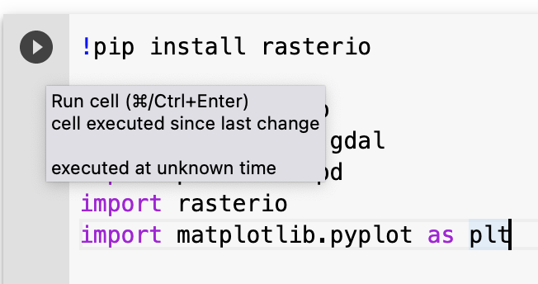

1. If you aren’t currently signed into your Google Account, it will now ask you to sign in.

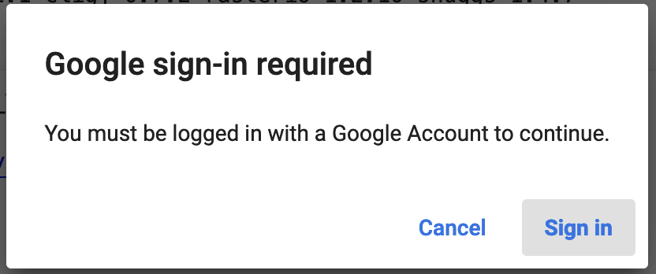

1. You will also be notified that this notebook is not built by Google. Please click “Run Anyway

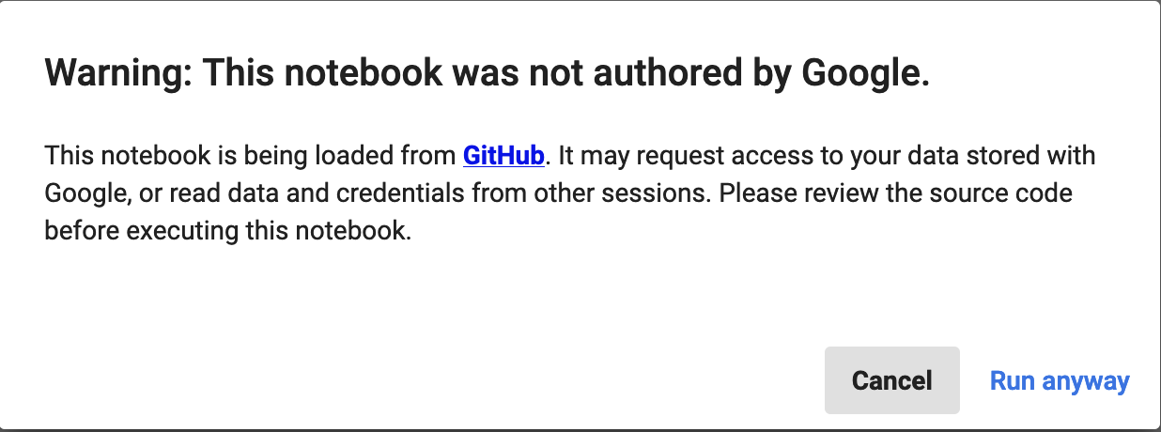

1. You will also be asked for 2 permissions to get access to your Google Credentials and Google Drive. If you don’t allow it, you won’t be able to access the files needed for the tutorial. You may be prompted to do this multiple times throughout the workshop.

First permission

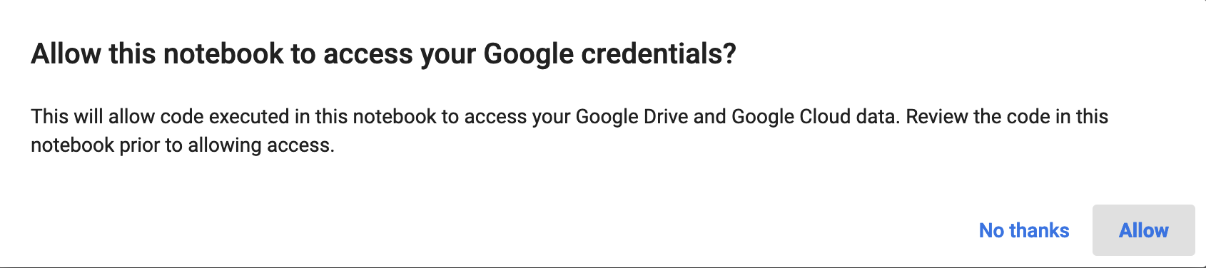



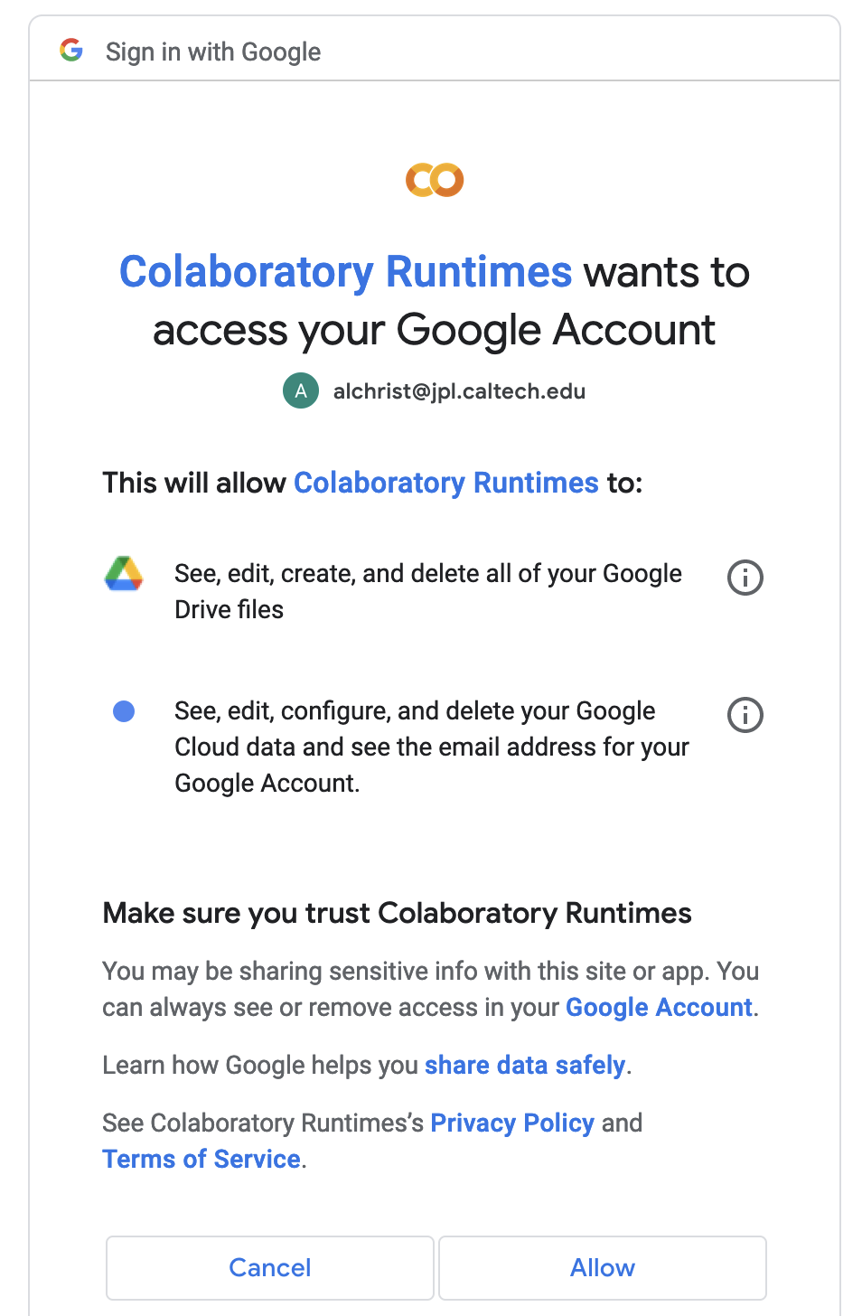

Second permission

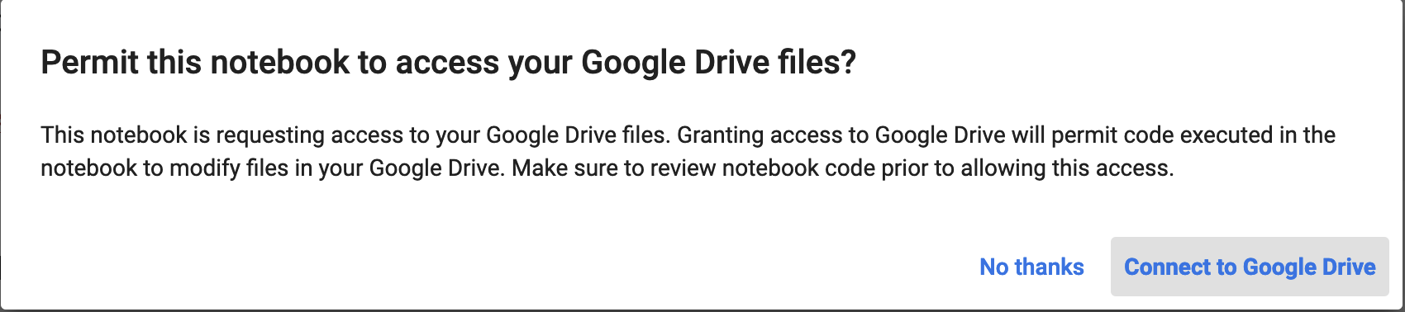****

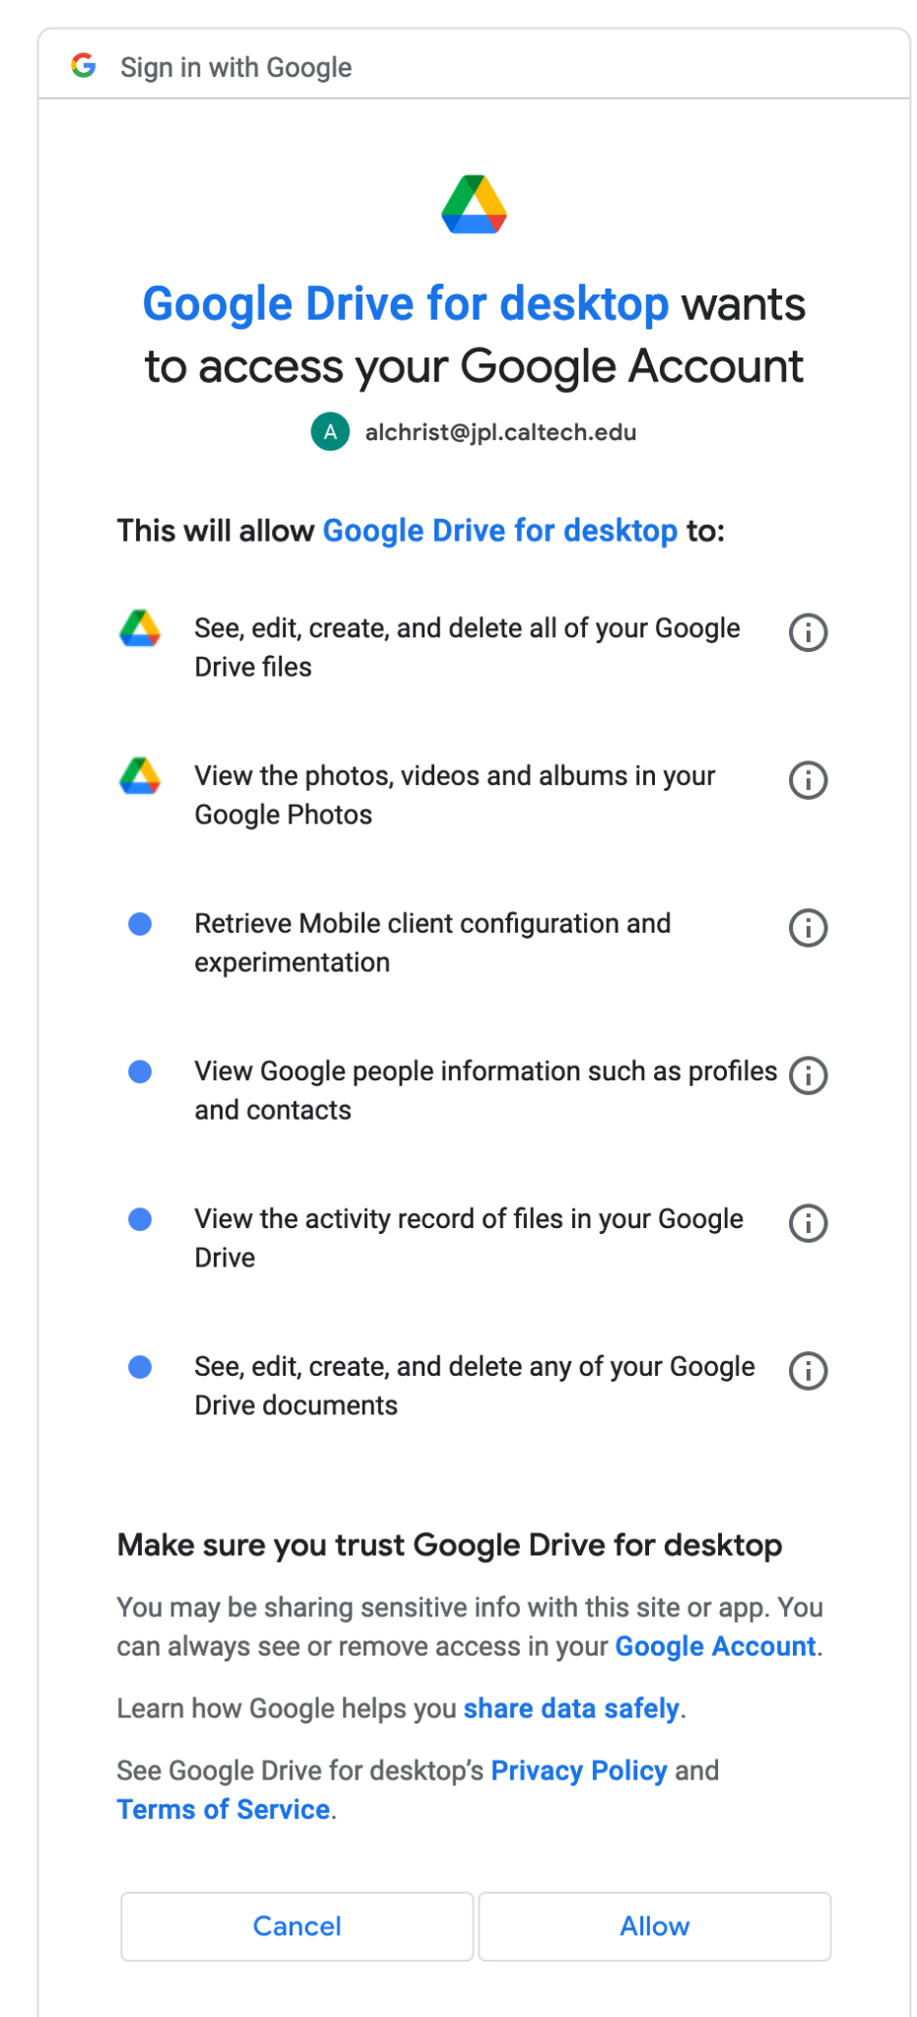

1. If the first cell runs smoothly, the packages should install and Colab should now have access to your Drive folders. You should see a small green check mark on the upper left corner if the cell ran successfully.

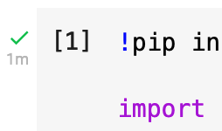

1. Next you will see instructions for linking the shared Google Drive (DeltaX_Workshop) to your Colab notebook. This is done by going to<https://drive.google.com/drive/folders/1KQIQPNowinFYQGd7SvpUE2sHPS0ALueV?usp=sharing> and adding a shortcut to your drive.

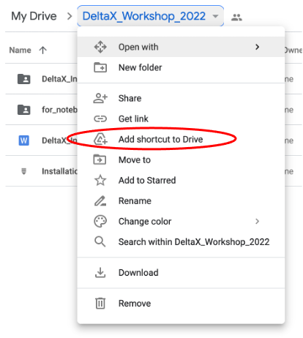

Make sure “My Drive” is highlighted, then click “ADD SHORTCUT”.

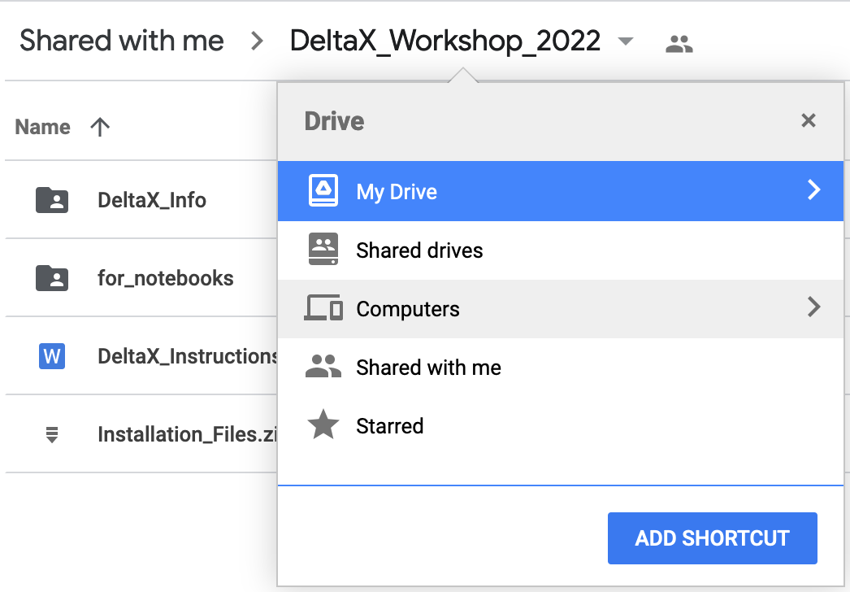

1. Then you can proceed to run the 2nd and 3rd cells in the notebook. If everything is connected properly, this should run without any problem and plot a map that looks like this:

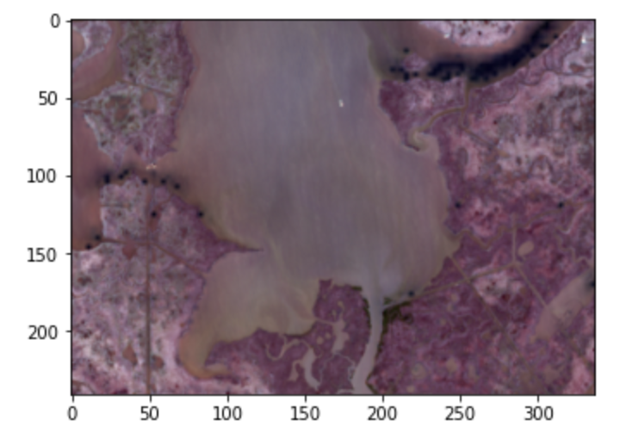

If you run into any problems with this process, please reach out to [alexandra.l.christensen@jpl.nasa.gov](mailto:alexandra.l.christensen@jpl.nasa.gov)

# Section 8: Data Access

Data collected as part of Delta-X are processed and quality assessed by the science team. Once this process is complete, data are curated and made publicly available through the Oak Ridge National Laboratory Distributed Active Archive Center. At this time, several datasets are available through the ORNL website (<https://daac.ornl.gov/>) and can be found by searching for “Delta-X”. However, most datasets are still in preprint form and await final approval before release. As part of this workshop, you will be given direct access to these data with the understanding that these data are preliminary and not yet approved for final release.

In order to access data through the ORNL DAAC, you will need to create a NASA Earth Data account.

When you reach the ORNL website (<https://daac.ornl.gov/>), you will see a **Sign in** button.

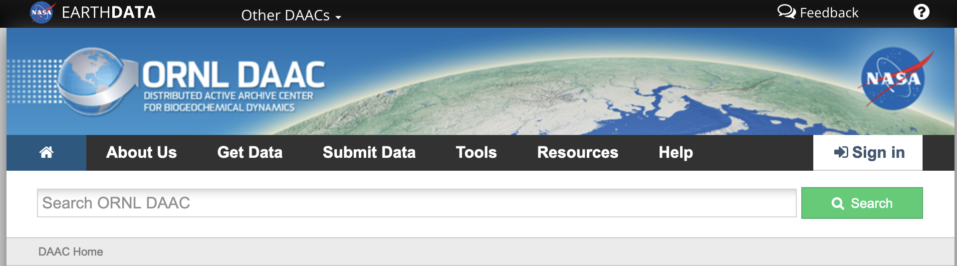

Clicking this takes you to a login page, where you can register for a Earth Data account (if you don’t already have one)

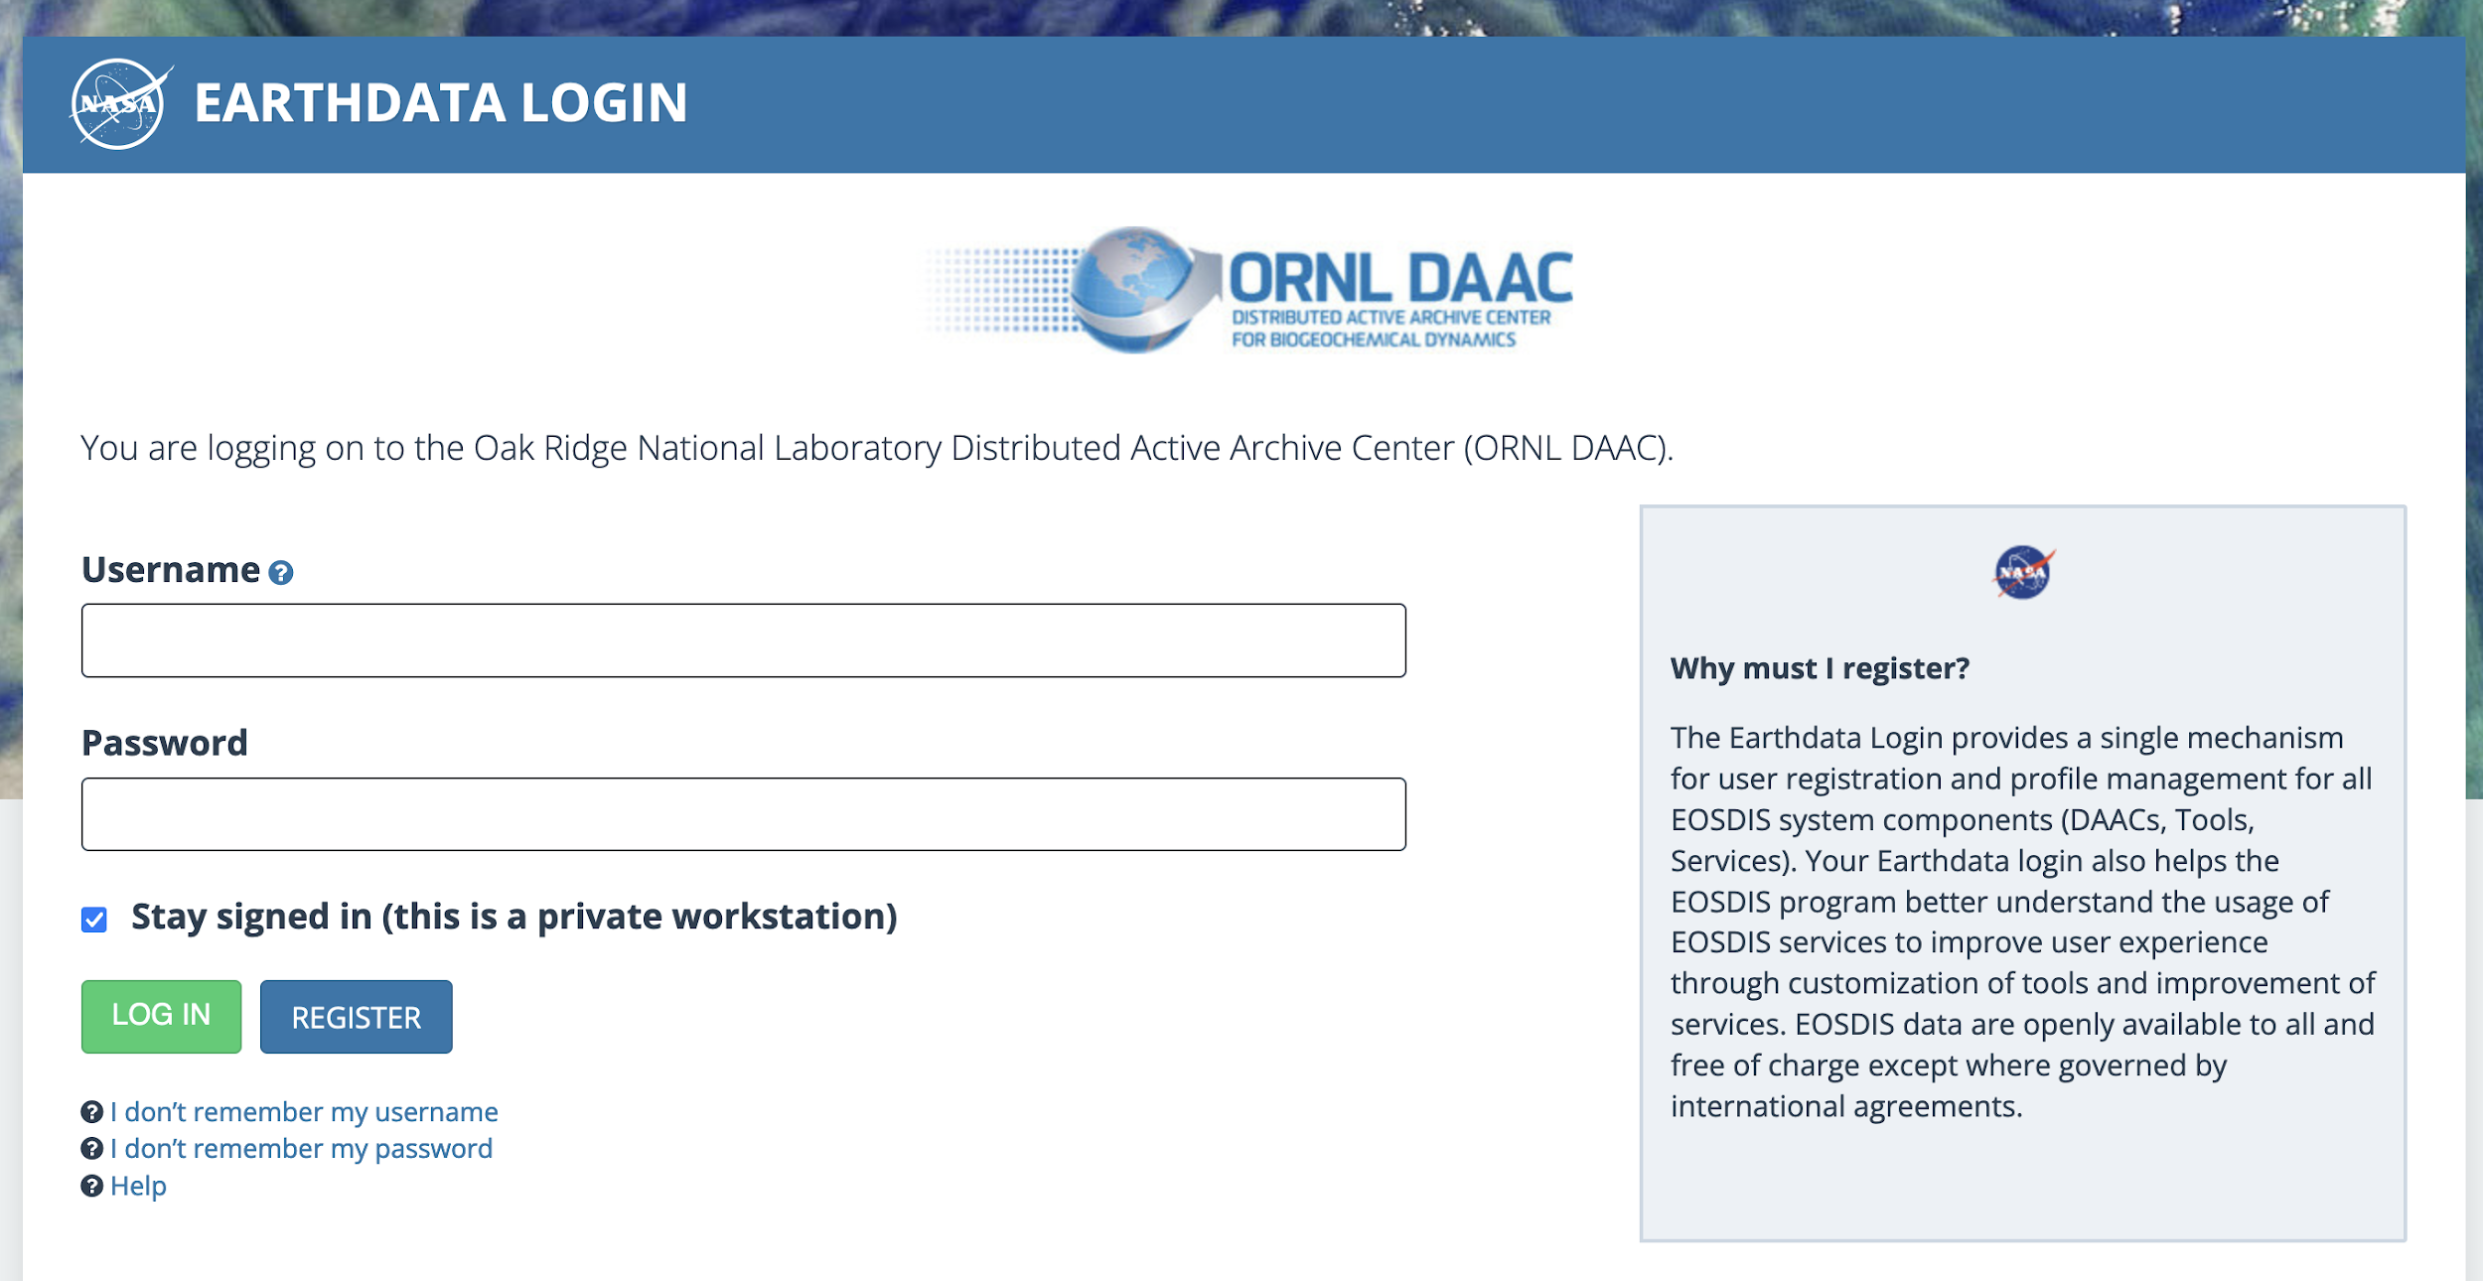

To create your account, click on the blue REGISTER button then fill out the registration form.

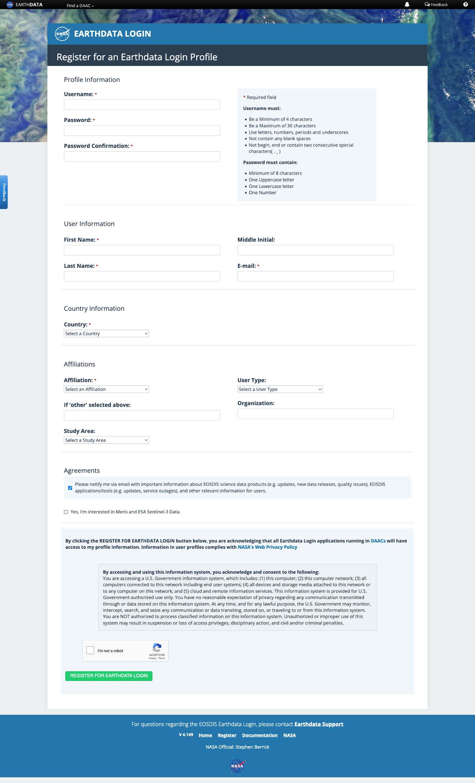

Once you have registered and logged in, you can begin by searching the archive using the search box near the top. The spring ADCP dataset will be used as an example.

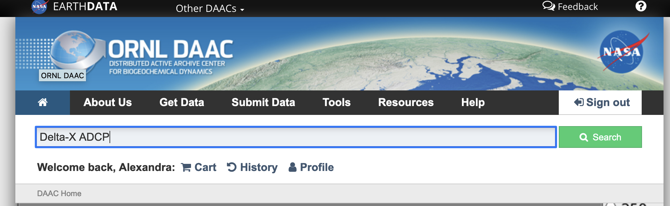

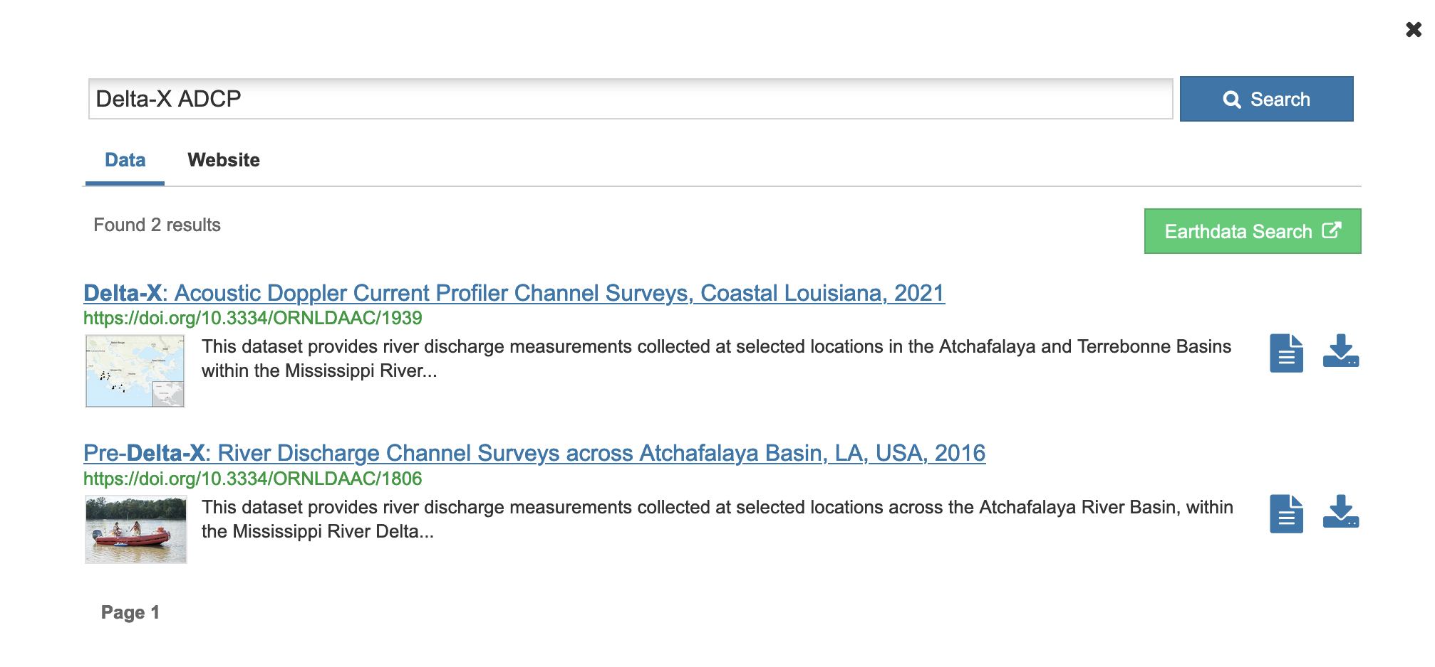

You’ll notice 2 datasets appear. The first is the one you will download. The second is a dataset from the Pre-Delta-X campaign in 2016.

By clicking on the first entry, you will be taken to the page for the ADCP dataset. This will show a brief description, dates of publication, a citation, and the data files available. If you see the banner “A newer version exists” please click on the DOI link provided:

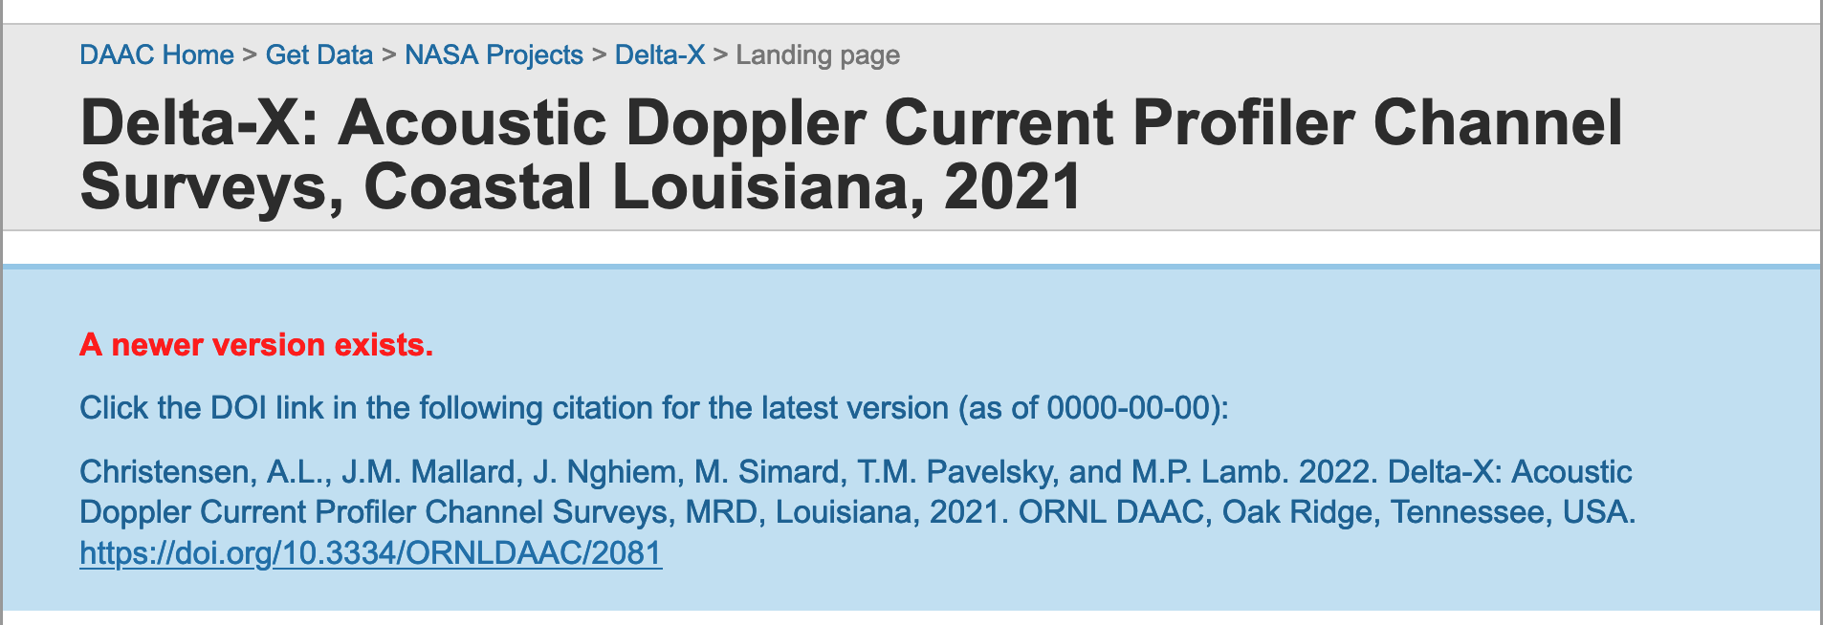

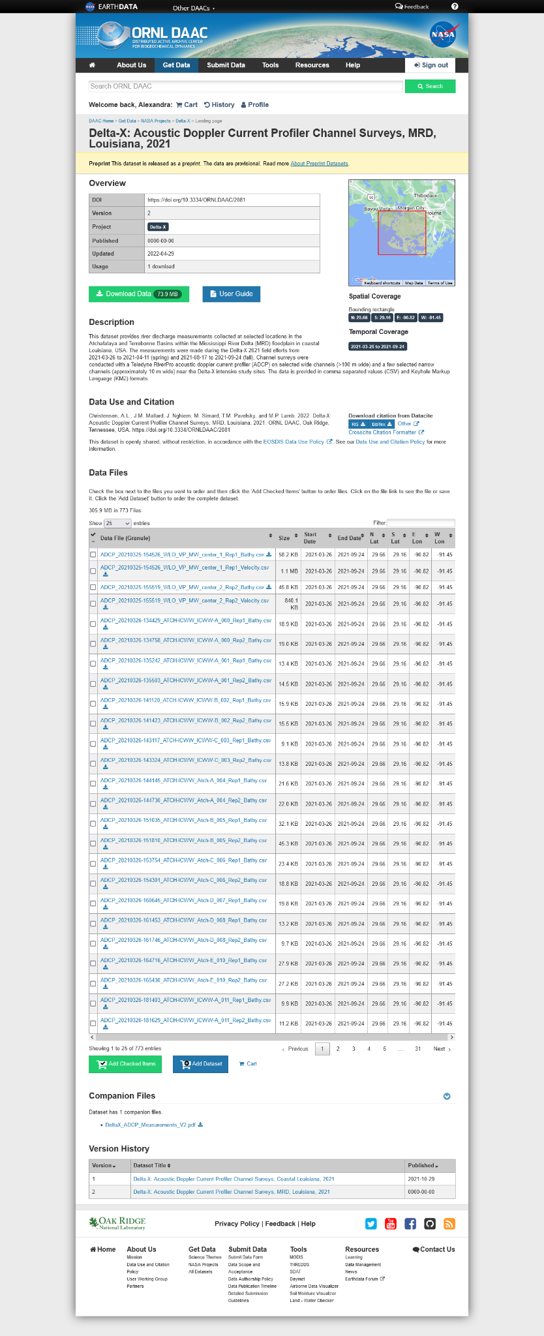

You can download all of the data and the user guide using the green and blue buttons at the top of the page. 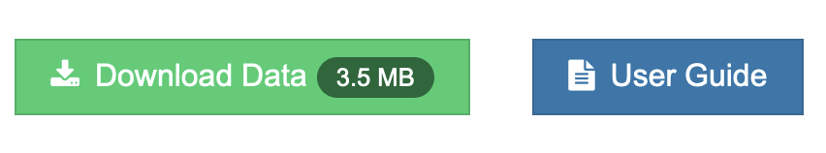

Or you can download individual files at the bottom of the page. You can use the filter search box to find specific files, then use the download buttonto download individual files.

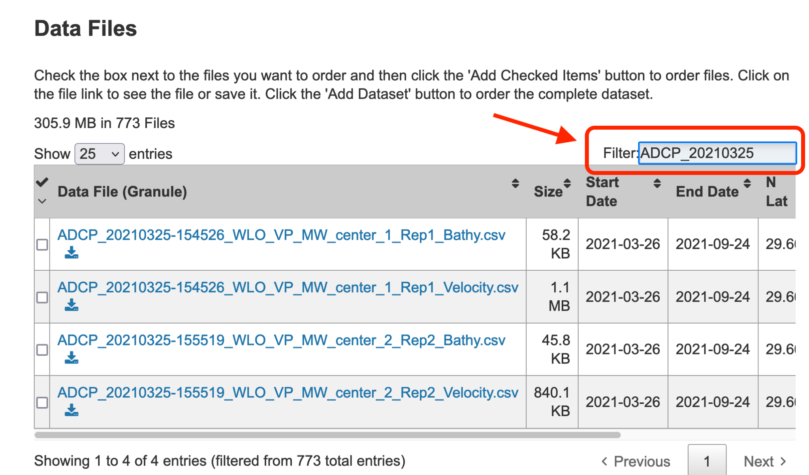

This is an example of a preprint dataset that is also searchable. However, most of the datasets are only available as preprints that are not searchable on the ORNL website. Instead, we have provided direct links for participants in the Delta-X workshop. See below for more instructions.

## Module Data

The datasets needed to run the modules in each tutorial using software installed on your own computer (not Google Colab) are listed below. Total file size will be larger than 15GB so make sure you have sufficient space on your device.

**Data that are searchable on ORNL will be listed as such. Those that are available as preprints will have a direct link. The remaining datasets are hosted on Google Drive.**

Each dataset has a user guide with detailed information about collection, processing, and data format.

### Field Data

Please save each of these files into a folder in your working directory (FIELD).

* **Module 1: Biomass**
  + The aboveground and belowground biomass datasets are searchable through ORNL DAAC. Please download both datasets.

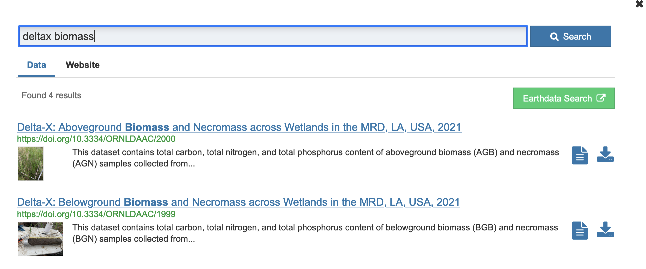

* **Module 2: Sediment Accretion**
  + Feldspar Sediment Accretion Measurements: <https://daac.ornl.gov/cgi-bin/dsviewer.pl?ds_id=2079>
* **Module 3: ADCP** 
  + This dataset is searchable through ORNL DAAC. Please download the entire dataset.
  + <https://daac.ornl.gov/cgi-bin/dsviewer.pl?ds_id=2081>
* **Module 4: Gauges** 
  + This dataset is not available through ORNL yet. You can find a subset of these data on the Google Drive >> 40DeltaX_Workshop_2022/Tutorials/0_Field/Module4_Gauges) <https://drive.google.com/drive/folders/1oADB57znBUkJr0lTx1rVN_Kz2GBFNxBU?usp=sharing>
* **Module 5: Water Quality and Total Suspended Solids**
  + In Situ Water Quality Indicators: <https://daac.ornl.gov/cgi-bin/dsviewer.pl?ds_id=2080>
  + Total Suspended Solids Concentration across MRD, LA, USA, 2021: <https://daac.ornl.gov/cgi-bin/dsviewer.pl?ds_id=2075>
* **Module 6: Sediment Grain Size**
  + Bed and Suspended Sediment Grain Size, Wax Lake Delta: <https://doi.org/10.3334/ORNLDAAC/2061>

### AVIRIS-NG

Please save each of these files into a folder in your working directory (AVIRISNG).

* AVIRIS-NG L2 Surface Reflectance Products across the MRD: <https://doi.org/10.3334/ORNLDAAC/1988>. Please download these files:
  + ang20210401t150456_rfl
  + ang20210401t150456_rfl.hdr
* PreDeltaX_WaterReflectance+TSS_Atchafalaya_Fall2016
  + You can find a subset of these data on the Google Drive >> DeltaX_Workshop_2022/Tutorials/1_AVIRIS-NG) <https://drive.google.com/drive/folders/1x2daBncvJvsPXfuteaCpzTpoqa5DOtFW>
  + Download the file “PreDeltaX_WaterReflectance+TSS_Atchafalaya_Fall2016.csv” by right-clicking on the file name then clicking on the “Download” from the pop-up menu.

### AirSWOT

Please save each of these files into a folder in your working directory (AIRSWOT).

* AirSWOT L2 Geocoded Water Surface Elevation, LA, USA, 2021: <https://doi.org/10.3334/ORNLDAAC/2070>
  + utm_m0m_20210326171437.err.tif
  + utm_m0m_20210326171437.hgt.tif
  + utm_m0m_20210326171437.inc.tif
  + utm_m0m_20210326194454.err.tif
  + utm_m0m_20210326194454.hgt.tif
  + utm_m0m_20210326194454.inc.tif
  + utm_m0m_20210327142430.err.tif
  + utm_m0m_20210327142430.hgt.tif
  + utm_m0m_20210327142430.inc.tif
  + utm_m0m_20210327164503.err.tif
  + utm_m0m_20210327164503.hgt.tif
  + utm_m0m_20210327164503.inc.tif
  + utm_m0m_20210401124406.err.tif
  + utm_m0m_20210401124406.hgt.tif
  + utm_m0m_20210401124406.inc.tif
  + utm_m0m_20210401152540.corr.tif
  + utm_m0m_20210401152540.dhdphi.tif
  + utm_m0m_20210401152540.err.tif
  + utm_m0m_20210401152540.hgt.tif
  + utm_m0m_20210401152540.inc.tif
  + utm_m0m_20210401152540.mag_ns.tif
  + utm_m0m_20210401152540.mag.tif
  + utm_m0m_20210412191209.hgt.tif
  + utm_m0m_20210412224621.hgt.tif
  + utm_m0m_20210416005432.hgt.tif
  + utm_m0m_20210416041720.hgt.tif
  + utm_m0m_20210418164312.hgt.tif
  + utm_m0m_20210418202023.hgt.tif
* Pre-Delta-X: L3 AirSWOT-derived Water Level Profiles
  + Search the ORNL DAAC for “pre-deltax airswot L3” data and download the entire package from the first link (the Feb 18, 2021 dataset).

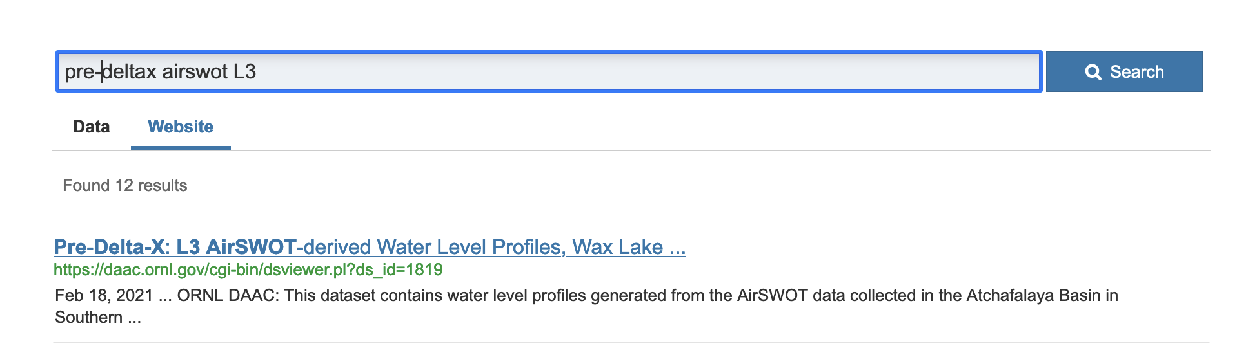

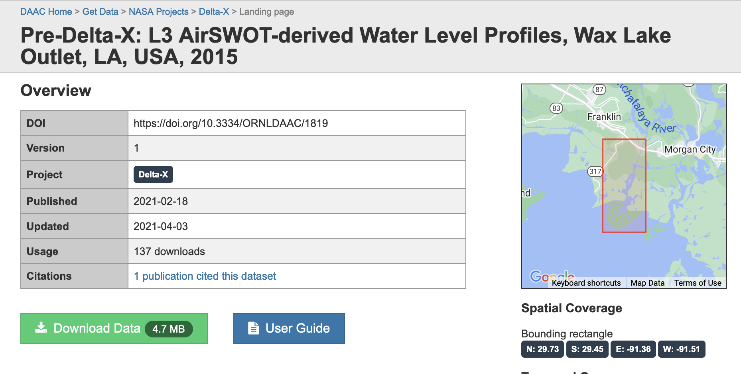

* A water mask file (stored on the Google Drive >> DeltaX_Workshop_2022/Tutorials/2_AirSWOT)
  + <https://drive.google.com/drive/folders/1windaRWzje3oDFlo6nD89yawF-KjG7sY?usp=sharing>
* Water level gauges data (stored on the Google Drive >> DeltaX_Workshop_2022/Tutorials/2_AirSWOT)
  + <https://drive.google.com/drive/folders/1wX_LJdyuuAzaFsdKQ5MaYWpyOOmFAhTP?usp=sharing>

### UAVSAR

Please save each of these files into a folder in your working directory (UAVSAR).

* UAVSAR Level 3 Geocoded InSAR Derived Water Level Changes, LA, USA, 2021: <https://doi.org/10.3334/ORNLDAAC/2058> Please download these files (you can find all 14 files by searching for “wterre_34202_210406” using the “Filter” text box):
  + wterre_34202_2104061728_2104061728_01_waterlevelchange.grd.dat
  + wterre_34202_2104061728_2104061728_01_waterlevelchange.grd.dat.hdr
  + wterre_34202_2104061728_2104061800_01_waterlevelchange.grd.dat
  + wterre_34202_2104061728_2104061800_01_waterlevelchange.grd.dat.hdr
  + wterre_34202_2104061728_2104061831_01_waterlevelchange.grd.dat
  + wterre_34202_2104061728_2104061831_01_waterlevelchange.grd.dat.hdr
  + wterre_34202_2104061728_2104061902_01_waterlevelchange.grd.dat
  + wterre_34202_2104061728_2104061902_01_waterlevelchange.grd.dat.hdr
  + wterre_34202_2104061728_2104062032_01_waterlevelchange.grd.dat
  + wterre_34202_2104061728_2104062032_01_waterlevelchange.grd.dat.hdr
  + wterre_34202_2104061728_2104062102_01_waterlevelchange.grd.dat
  + wterre_34202_2104061728_2104062102_01_waterlevelchange.grd.dat.hdr
  + wterre_34202_210406_01_temporalcoherence.grd.dat
  + wterre_34202_210406_01_temporalcoherence.grd.dat.hdr
* UAVSAR Level 2 Geocoded Interferometric Products, LA, USA, 2021: <https://doi.org/10.3334/ORNLDAAC/2057> Please download these files (you can find all 8 files by searching for “wterre_34202_2104061800_2104062032” using the “Filter” text box):
  + wterre_34202_2104061800_2104062032_01_coh.grd.dat
  + wterre_34202_2104061800_2104062032_01_coh.grd.dat.hdr
  + wterre_34202_2104061800_2104062032_01_intamp.grd.dat
  + wterre_34202_2104061800_2104062032_01_intamp.grd.dat.hdr
  + wterre_34202_2104061800_2104062032_01_intphase.grd.dat
  + wterre_34202_2104061800_2104062032_01_intphase.grd.dat.hdr
  + wterre_34202_2104061800_2104062032_02_unwphase.grd.dat
  + wterre_34202_2104061800_2104062032_02_unwphase.grd.dat.hdr
* UAVSAR Level 1B: This is available in final form through ORNL. Search for “Delta-X UAVSAR L1B”. Please download these files:

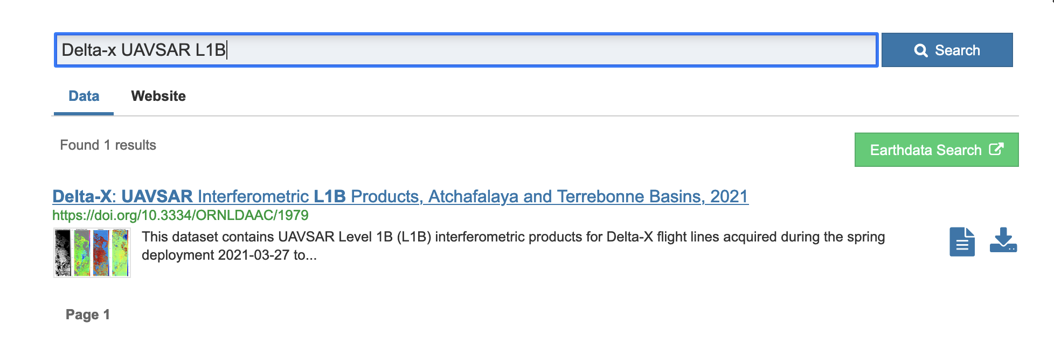

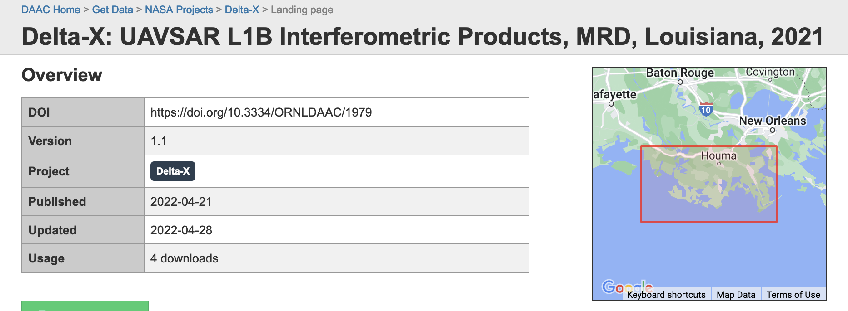

Search for “wterre_34202_2104061800_2104062032_01” using the “Filter” search box, then download and unzip the 4 resulting files. You should end up with the following 8 files:

* + wterre_34202_2104061800_2104062032_01_coh.dat
  + wterre_34202_2104061800_2104062032_01_coh.hdr
  + wterre_34202_2104061800_2104062032_01_intamp.dat
  + wterre_34202_2104061800_2104062032_01_intamp.hdr
  + wterre_34202_2104061800_2104062032_01_intphase.dat
  + wterre_34202_2104061800_2104062032_01_intphase.hdr
  + wterre_34202_2104061800_2104062032_01_unwphase.dat
  + wterre_34202_2104061800_2104062032_01_unwphase.hdr

### ANUGA

You don’t need to download any files for this tutorial.

### Delft3D

If you are using a PC, you can run Delft3D. If you are using a Mac, you won’t be able to run Delft3D, but you can follow along with the instructor. Please save the folder “Simulation” into your working directory (Delft3D) by right clicking the folder then clicking “Download”. Google Drive will take some time to generate a zip file for you to download. Make sure to unzip it.

These files are available on the Google Drive >> DeltaX_Workshop_2022/Tutorials/5_Delft3D)

<https://drive.google.com/drive/folders/1ZARCu82vQFZ0rvrb6JukINjtnrEB6ZKM?usp=sharing>